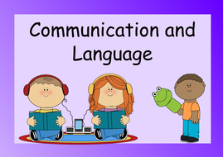  The children will be listening to a range of poems, stories and rhymes to develop their listening and attention skills. They will be using stem sentences to develop their spoken language and Talking Time linked to Phonics.  Home Learning  Rhymes  Here we go round the mulberry bush - BBC Teach  Five Little Aliens - https://www.youtube.com/watch?v=gQpAwxBt5eY  The bear went over the mountain https://www.bbc.co.uk/iplayer/episode/p09szzqx  Developing conversations at home  Alternative conversation starters about the school day  Supporting children's early communication skills - Speech and Language UK: Changing young lives  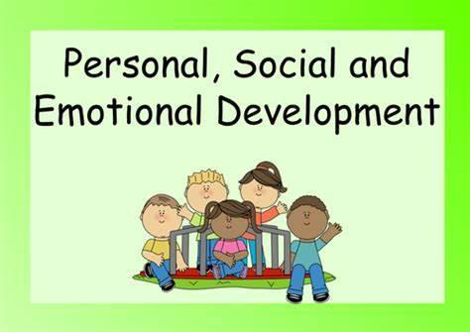  We use the scheme of work Jigsaw. The theme this term is ‘Dreams and Goals’. The children will talk about the following:  - To understand what a challenge means  - To keep trying until they can do something  - To set a goal and work towards it  - To know some kind words to encourage people with  - To start to think about the jobs I might like to do when I’m older  - To feel proud when they achieve a goal  To develop gross and fine motor skills.  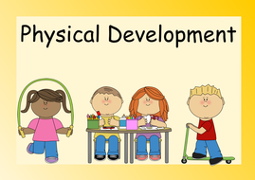  Fine motor: the children will start by mark make, learn how to make snips using scissors safely, use small and large construction and begin to trace the letters in their name.  Gross motor: the children will develop their crawling, walking, running, jumping, hopping, skipping, creeping and slithering, spinning, turning, twisting, pushing and pulling skills. |  | Early Years  Nursery Fir  Spring Term 1 2025  Topic: Journeys    Themes  Winter  Positional Language  Space  Journeys
 |  |  |  |  |  | 
 |  | 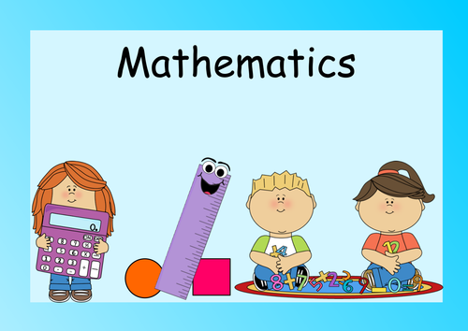  We will be using ‘White Rose’ to support the teaching of mathematics.  - Recite numbers past 5.  - Notice patterns and arrange things in patterns.  - Develop fast recognition of up to 3 objects, without having to count them individually (‘subitising’ - the ability to instantaneously recognise the number of objects in a small group without the need to count them ).  - Make comparisons between objects relating to weight  Home Learning  See the amount https://www.bbc.co.uk/bitesize/topics/zs3j2v4/articles/zf3r96f  Bud’s number garden  https://www.bbc.co.uk/bitesize/topics/zs3j2v4/articles/zd4b382  Some Number songs to support:  https://www.youtube.com/watch?v=HtNdJ6zWgZc  https://www.bbc.co.uk/teach/school-radio/articles/zr88bdm |  |  |  | 5 things for getting ready for school  - Practice washing hands independently  - Practice taking your coat off and putting it back on  - Practice putting on your school shoes  - Share your toys with a friend or someone in your family  - Prepare and try different fruits and vegetables
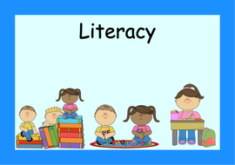  Reading Comprehension  We will be listening to a range of stories related to our Topic.  - I can see a Snowman - What can you see on a winter walk?  - We're going on a Bear Hunt - Who would you take with you if you were going on a bear hunt  - Whatever Next - What would you take to the moon?  - Train Ride - What might I see out of the train window on a train ride?  Reading at home with your child helps parents by starting the journey of building a lifelong love of reading for pleasure. Parents are giving their child the opportunity to be the best they can be.  I |  |  |  |  |  | 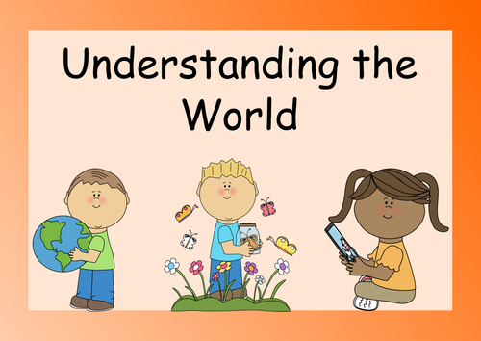  Our focus is:  - Past and Present  - People and Communities  - The Natural World  In Geography we are going to travel around the map to visit a setting.  Using a small world and objects, we will create a map of a train journey and describe what you see.  In History we will learn about Neil Armstrong - Who was he? What did he do? Why is he famous? What is it like in space?  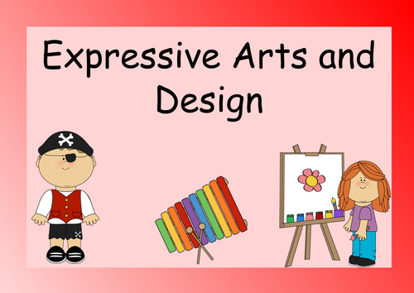  For Art and Design, we will do observational drawing of winter objects using pictures or artefacts, compare paintings by John Constable,(an African landscape artist, Explore different ways to apply paint.), explore using oil pastels, crayons, creating a landscape of a forest based on the story ‘We’re going on a bear hunt’ and using different ways of joining materials to make a train - Junk modelling.  Music will be taught on Monday following the scheme ‘Music Sing Up’ and this half term it will be Travel and Movement - Unit 2.  .
Phonics

We will be following a new phonic scheme ‘Monster Phonics’. We will focus on listening and identifying sounds all around us through
Environmental Sounds - natural and man-made sounds such as human and animal vocalisations, water and weather-related events, mechanical and electronic signalling sounds.
Instrumental Sounds - is music normally without any vocals, although it might include some inarticulate vocals.
Body Percussion - is a fusion of movement and sound.
Rhythm and Rhyme - Rhythm refers to the pattern of stressed and unstressed syllables in a line of verse, which can create a musical or metrical effect. Rhyme, on the other hand, refers to the repetition of sounds at the end of words, which can create a pleasing or memorable effect.
Alliteration - is a literary device that involves two or more words that appear close together and have the same initial stressed consonant syllable.
Voice Sounds - Show children how they can make sounds with their voices, for example: Make your voice go down a slide – wheee!

Home Learning
Phonics Phase 1 - games
https://www.phonicsplay.co.uk/resources/phase/1
Nursery Rhymes
Here we go round the mulberry bush - https://www.bbc.co.uk/teach/school-radio/articles/z7jgscw
Incy Wincy Spider - https://www.bbc.co.uk/teach/school-radio/articles/zr4yt39

Twinkle Twinkle - https://www.bbc.co.uk/teach/school-radio/articles/zds6jhv
Hickory Dickory Dock -https://www.bbc.co.uk/teach/school-radio/articles/znpj47h

