|  |  |  |  |  |  |
| --- | --- | --- | --- | --- | --- |
| EYFS 7 Areas Of Learning Posters | Teaching Resources To develop communication and language skills please use google to listen to the stories outlined below  **Core Stories**  Polar Bear, Polar Bear What do you Hear?  Penguin Small  The Great Race  We’re Going on a Lion Hunt  Dinosaur Roar  Nursery rhymes are a great way to develop listening and attention skills and phonological awareness. Click on the links below to listen to the rhymes.  **Home Learning**  **Rhymes**  [Here we go round the mulberry bush - BBC Teach](https://www.bbc.co.uk/teach/school-radio/articles/z7jgscw)  [The bear went over the mountain - BBC Teach](https://www.bbc.co.uk/teach/school-radio/articles/zmssmfr)  I’m a little Penguin  [Guidance for Video/Audio in PowerPoints](https://www.stjosephsinfants.ie/wp-content/uploads/2021/01/penguin-rhyme-pp.pdf)  [Down in the jungle - BBC Teach](https://www.bbc.co.uk/teach/school-radio/articles/zfqgscw)  [Dinosaurs - BBC Teach](https://www.bbc.co.uk/teach/school-radio/articles/zv7rf4j)  **Developing conversations at home**  [Alternative conversation starters about the school day](https://www.theschoolrun.com/35-questions-ask-your-child-instead-how-was-your-day)  [Supporting children's early communication skills - Speech and Language UK: Changing young lives](https://speechandlanguage.org.uk/help-for-families/resource-library-for-families/supporting-childrens-early-communication-skills/) EYFS 7 Areas Of Learning Posters | Teaching Resources **The theme this term is Dreams and Goals**  Piece 1Challenge: I understand that if I persevere, I can tackle challenges  Piece 2 Never Giving Up: I can tell you about a time I didn’t give up until I achieved my goal  Piece 3 Setting a Goal: I can set a goal and work towards it  Piece 4 Obstacles and Support-I can use kind words to encourage people  Piece 5 Flight to the Future-I understand the link between what I learn now and the job I might like to do when I’m older  Piece 6 Footprint Awards- I can say how I feel when I achieve a goal and know what it means to feel proud |  | **Early Years Reception Pine**  Spring 1 2025  **Topic: Footprints**  Themes  Signs of Winter  Footprints in cold climates  Chinese New Year  Footprints in hot climates  Dinosuars |  | |  |
|  | **Come to school with your book bag, drink bottle and coat only** |  | |
| 2000x500 | | | |
|  |
| EYFS 7 Areas Of Learning Posters | Teaching Resources  **Gross Motor Skills**  **PE will be taught be Miss Bowers on a Friday afternoon.**  **Please ensure your child is dressed for PE so that they can actively take part.**  This term the theme is ‘Hands’. The children will be learning the following skills   * To throw a beanbag underarm and overarm * To explore different ways of rolling a ball using our hands * To explore different ways of stopping a ball using our hands * To catch a beanbag and a small ball   **Fine Motor Skills**  This term the focus will be on number and shape formation, cutting skills, Phase 2 phonics and reading real books |  | EYFS 7 Areas Of Learning Posters | Teaching Resources  **Home Learning**  **Reading and Comprehension**  Use monster phonics ebooks to access reading books  **The importance of reading aloud to your child at home provides relaxation, time together, routines and love of reading and helps parents to bond with their child. By starting this journey of building a lifelong love of reading for pleasure, you will give your child the opportunity to be the best they can be. Children who read for pleasure do better in a wide range of subjects at school and it also positively impacts children’s wellbeing.**  When reading library books to your child think about asking the following questions   * What is happening in the picture? * How is the character feeling? * Where does the story take place? * When did the story take place? * Describe the main character – young, old, friendly, miserable, lonely, popular * Why do you think the character did that? * What will happen next? | |  | Home Learning  Revise Term 1 Words by use the flashcards that were sent home to practise reading the words by segmenting and blending and spell them in read books provided.  **High frequency words**  Go, no, to, into, I the  **Decodable Words**  A, an, at, if, in, it, off, on, can, dad, had, him, back, and, get, big, got, up, not, mum, but, put  **Tricky words**  As, is, his, of  Term 2 words  **High Frequency Words**  We, be,me, he, she, you, my, they, was, her, all, are  **Decodable Words**  Will, for, that, this, then, them, with, look, see, too, now, down  What are Finger Spaces? | Twinkl Teaching Wiki - Twinkl  **Phonics**  Week 1-ar (car, star, far)  Say the sentence, write the sentence:  ***We are on the farm.***  Week 2-oo (look, book, took)  Say the sentence, write the sentence:  ***I will cook good food.***  Week 3-ow (down, town, frown)  Say the sentence, write the sentence:  ***I went to the town.***  Week 4-ee (see, bee, sheep)  Say the sentence, write the sentence:  ***I can see green trees.***  Week 5-ur (fur, hurt, purse)  Say the sentence, write the sentence:  ***They are not hurt.***  Week 6-ai (rain, train, main)  Say the sentence, write the sentence: |

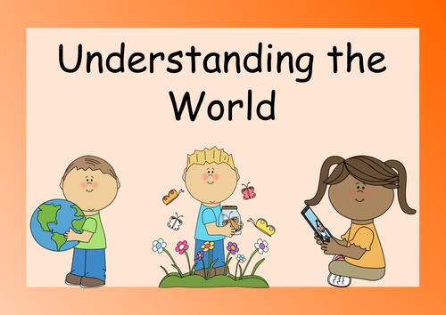

**Past and Present**

* Who found the first fossil? Facts about Mary Annings

**People and Communities**

* How is the Chinese New Year celebrated**?**

**The Natural World**

* How do we know it is winter? What are the signs?
* What do we wear in winter? Why?
* What does salt do to ice?
* What animals live in the Polar regions?
* Where do penguins live? Why do they have an oily coat?
* How is Africa different or the same to where we live?

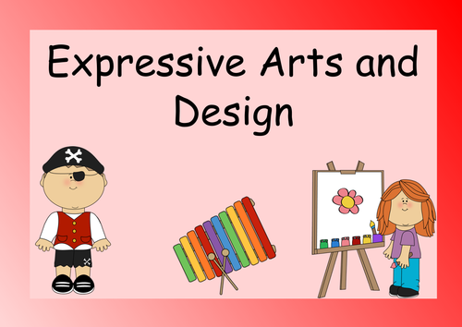

* To use the painting ‘The Road to Giverney’ by Monet to explore mixing winter colours using various tools
* Observational drawings of animals that live in the polar regions
* Use egg boxes to create a 3D dragon, exploring ways to join and fix materials
* Observational drawing of African masks
* To use Modroc to create an African mask and decorate using various materials.

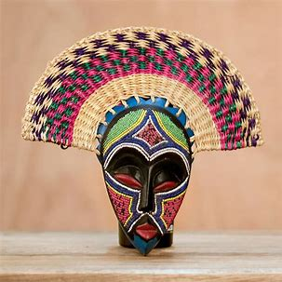

Music will be taught by a specialist teacher

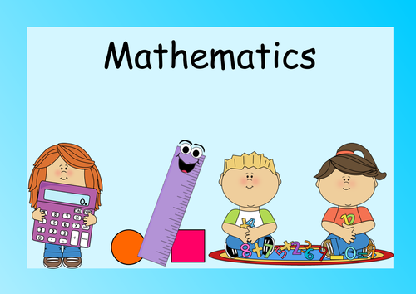

**Number Rhymes**

[One big hippo balancing - BBC Teach](https://www.bbc.co.uk/teach/school-radio/articles/zkfxwty)

[One man went to mow - BBC Teach](https://www.bbc.co.uk/teach/school-radio/articles/zjgnmfr)

[Five little speckled frogs - BBC Teach](https://www.bbc.co.uk/teach/school-radio/articles/zjjbnrd)

[Five little men in a flying saucer - BBC Teach](https://www.bbc.co.uk/teach/school-radio/articles/z6qgscw)

[The goats came marching - BBC Teach](https://www.bbc.co.uk/teach/school-radio/articles/zjqgscw)

**NCETM Mastery Mathematics**

Week 1- Comparing lengths by measuring using cubes

Week 2- Subitising to 5 (to instantly recognise number patterns on a dice face or dominoe)

Week 3- Counting to 5, 10, 20

Wek 4- Explore different ways of making 5, then 6 seeing the composition as 5 and a bit

Week 5- Comparing different amounts using the words more and fewer