Reception Homework – Summer Term 2 2023
Communication & Language  Can you tell your grown up some facts that you have learnt about saving our world?  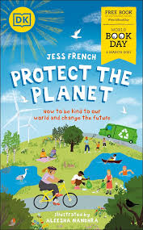 | PSED  Make a healthy eating poster. What do you need to do to keep healthy? Design a poster that will help everyone to stay healthy.  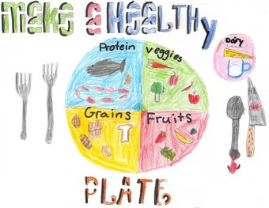 | Physical Development: Fine Motor  Practice forming lower- and upper-case letters  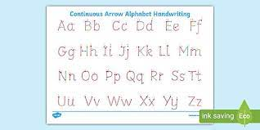 | Literacy  Imagine you have found a magic shell. You can have one wish. Write a sentence about your wish.  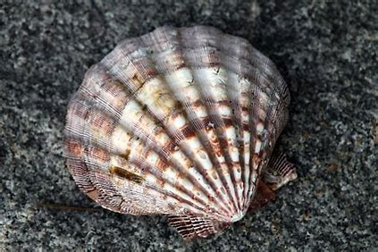  I wish I could swim with dolphins.  I wish to fly to the beach.
Maths  Can you get some fruits (grapes, strawberries, apples, oranges etc.) and half the amount?  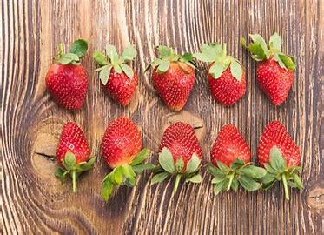  Half of 10 is 5. | Understanding the World  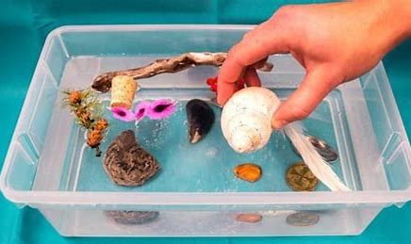  Have a look around your home and find two things that you think will float and 2 things that will sink. Ask a grown up to help you test if you are right | EAD  Design your own sea creature using junk modelling materials, paint, crayons, strings etc.  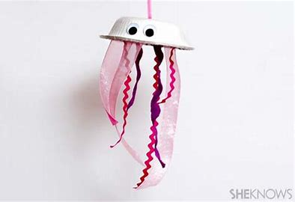  . | Transition  Begin to talk about moving to Year 1 with your child. When will it happen? Can they remember visiting the Year 1 classrooms? Do they have any questions?

