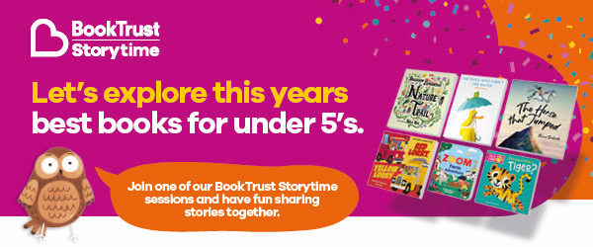
Join us at Borehamwood library for BookTrust Storytime. Starting on 12th January we will be enjoying 7 weeks of stories, songs and rhymes celebrating the fantastic BookTrust Storytime Prize shortlist, which aims to find the best picture book for sharing. Each interactive, 30-minute session will feature a different book from the shortlist, an activity, and a chance to vote towards the overall winner. These sessions are free (donations welcome) and ideal for children ages 2-5.
Join in the fun each week at Borehamwood library, 96 Shenley Road on Thursdays 4pm-4.30pm. We can’t wait to see you.
For more details, please visit https://bit.ly/HertsBTST23
We also have our My First Library card, available for children aged 0-5. It is free to join your local library where you will find a huge range of picture books, fact books and beginning to read stories to borrow. We think joining the library is exciting as there is so much to explore and be inspired by, to mark this special occasion children will be presented with a special certificate. This is part of our My Firsts promotion, helping families to celebrate those first early years milestones. You can find out more here: http://www.hertfordshire.gov.uk/myfirsts

