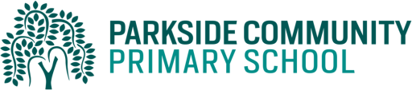
Dear Parents/Carers,
As part of our standards cup, children will help their class to earn points by completing their homework. The best way to help their class earn the points is to do their daily reading and spelling practice. Children must read to an adult and have their reading records signed daily. In addition, children can select from a variety of other activities from the table below. These activities will be in the last week of the half term Monday 23rd May. The children are expected to complete at least 3 of these activities per half term but may complete more if they choose. Children are also able to log into Education City and Purple Mash on a daily basis.
Activity 1 (Geography)  Create a fact file about a continent of your choice. Draw pictures to show what it is like and what you can see there. | Activity 2 (Science)  Complete Purple mash science activities about plants.
Activity 3 (Maths)  Login online and complete Education city activities online. | Activity 4 (English)  Login online and complete Education city activities online.
Activity 5 (PE)  Play a throwing game with your family, such as who can throw the farthest, who can hit a target. | Activity 6 (English)  Retell the story of farmer duck, you could use animal models, puppets or cuddly toys to help you.
Activity 7 (Science)  Go on a flower and plant hunt. Draw pictures or take photos of the plants you have seen. | Activity 8 (PHSE)  Pretend you have an upset friend. Write a letter to cheer up your friend.
Activity 9 (RE)  Think of something that is special to your family. Draw a picture and write about it. | Activity 10  An activity of your own choice

Thank you for supporting us with homework.
Kind regards,
The Year 1 team.

