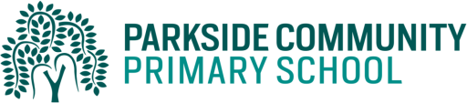
Dear Parents/Carers,
As part of our standards cup, children will help their class to earn points by completing their homework. The best way to help their class earn the points is to do their daily reading and spelling practice. Children must read to an adult and have their reading records signed daily. In addition, children can select from a variety of other activities from the table below. These activities will be in the last week of the half term Thursday 15th July. The children are expected to complete at least 3 of these activities per half term but may complete more if they choose. Children are also able to log into Mathletics, Education City and Purple Mash on a daily basis.
Activity 1 (DT)  Make your own pop up picture or moving picture scene. | Activity 2 (History)  Find out about a famous inventor, what did they invent? Why was it an important discovery?
Activity 3 (Maths)  Login and complete Education city activities online. | Activity 4 (English)  Login and complete Education city activities online.
Activity 5 (PE)  Make an exercise diary, try to include at least 3 activities each week. | Activity 6 (ART)  Make a  Be Safe in the Sun  Poster.
Activity 7 (Science)  Choose an animal and find out about its life cycle. Draw pictures to show the lifecycle. | Activity 8 (PHSE)  Make a timeline of your life that shows important changes, such as crawling, learning to walk and starting school.
Activity 9 (RE)  Find out about a religious story from Christianity, Islam or Judaism.  Draw a picture and write a few sentences to tell us the main events of the story. | Activity 10  An activity of your own choice

Thank you for supporting us with homework.
Kind regards,
The Year 1 Team

