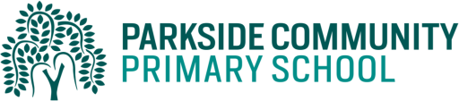

Dear Parents/Carers,
As part of our standards cup, children will help their class to earn points by completing their homework. The best way to help their class earn the points is to do their daily reading and spelling practice. Children must read to an adult and have their reading records signed daily. In addition, children can select from a variety of other activities from the table below. These activities will be in the last week of the half term Thursday 27th May. The children are expected to complete at least 3 of these activities per half term but may complete more if they choose. Children are also able to log into Mathletics, Education City and Purple Mash on a daily basis.
Activity 1 (Geography)  Create a fact file about a continent of your choice. | Activity 2 (Science)  Complete Purple mash science activities about plants.
Activity 3 (Maths)  Login online and complete Education city activities online. | Activity 4 (English)  Login online and complete Education city activities online. Write instructions on how to make your chosen food item (DT).
Activity 5 (PE)  Create a funky fitness dance. | Activity 6 (DT)  Make or bake a food item of your choice.
Activity 7 (Science)  Go on a flower and plant hunt. Draw pictures or take photos of the plants you have seen. | Activity 8 (PHSE)  Pretend you have an upset friend. Write a letter to cheer up your friend.
Activity 9 (RE)  Think of something that is special to your family. Draw a picture and write about it. | Activity 10  An activity of your own choice

Thank you for supporting us with homework.
Kind Regards,
The Year 1 Team

