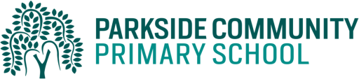

Dear Parents/Carers,
As part of our standards cup, children will help their class to earn points by completing their homework. The best way to help their class earn the points is to do their daily reading and spelling practice. Children must read to an adult and have their reading records signed daily. In addition, children can select from a variety of other activities from the table below. These activities will be in the last week of the half term Thursday 25th March. The children are expected to complete at least 3 of these activities per half term but may complete more if they choose. Children are also able to log into Mathletics, Education City and Purple Mash on a daily basis.
Activity 1 (History)  Choose a King or Queen to find out about. Make a poster. | Activity 2 (History)  Design a crown and a castle for your own King or Queen.
Activity 3 (Maths)  Login online and complete Mathletics activities online. | Activity 4 (English)  Login online and complete Education city activities online
Activity 5 (PE)  Create a gymnastics routine including travelling high and low, rolling and a movement of your choice. | Activity 6 (ART)  Create your own spring sculpture using dough/clay/plasticine.
Activity 7 (Science)  Choose an animal and find out about its life cycle. Draw pictures to show the lifecycle. | Activity 8 (PHSE)  Design a healthy lunchbox. Explain how you and your family live a healthy lifestyle.  Make a food diary recording what you eat in a week.
Activity 9 (RE)  Design a make an Easter bonnet / Easter hat | Activity 10  An activity of your own choice

Thank you for supporting us with homework.
Kind Regards,
The Year 1 Team

