**Tuesday 9th February 2021**



**LO: Can I describe the properties of 3D shapes?**

For this lesson, you will need to follow the link below to get to the video for this lesson.

You will need to watch the lesson very carefully and then complete the tasks below (you will do this throughout the lesson when asked). Alternatively, you can complete the tasks on Google Classroom.

<https://classroom.thenational.academy/lessons/to-describe-the-properties-of-3d-shapes-cdjkgd> - open in **Google Chrome**.

Warm Up Task:

Look at the following shapes:

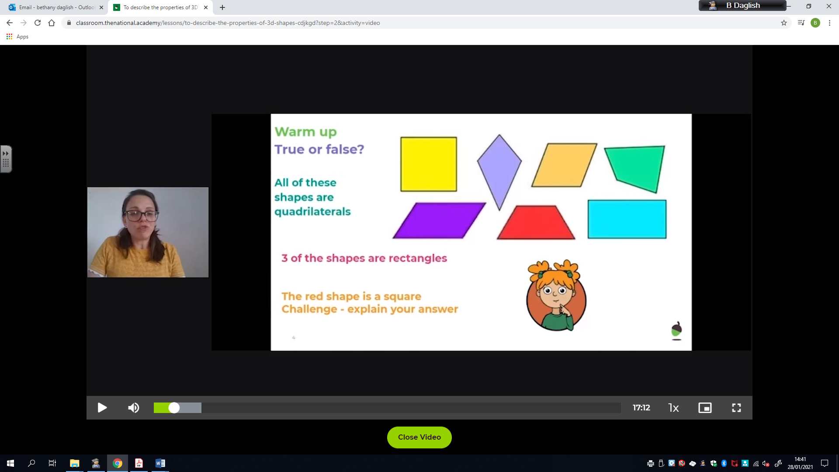

Answer TRUE or FALSE to the following statements:

1. ALL of these shapes are quadrilaterals =
2. 3 of the shapes are rectangles =
3. The red shape is a square =

Challenge – explain your answer to each statement.

Task 1:

What shapes can you see here?

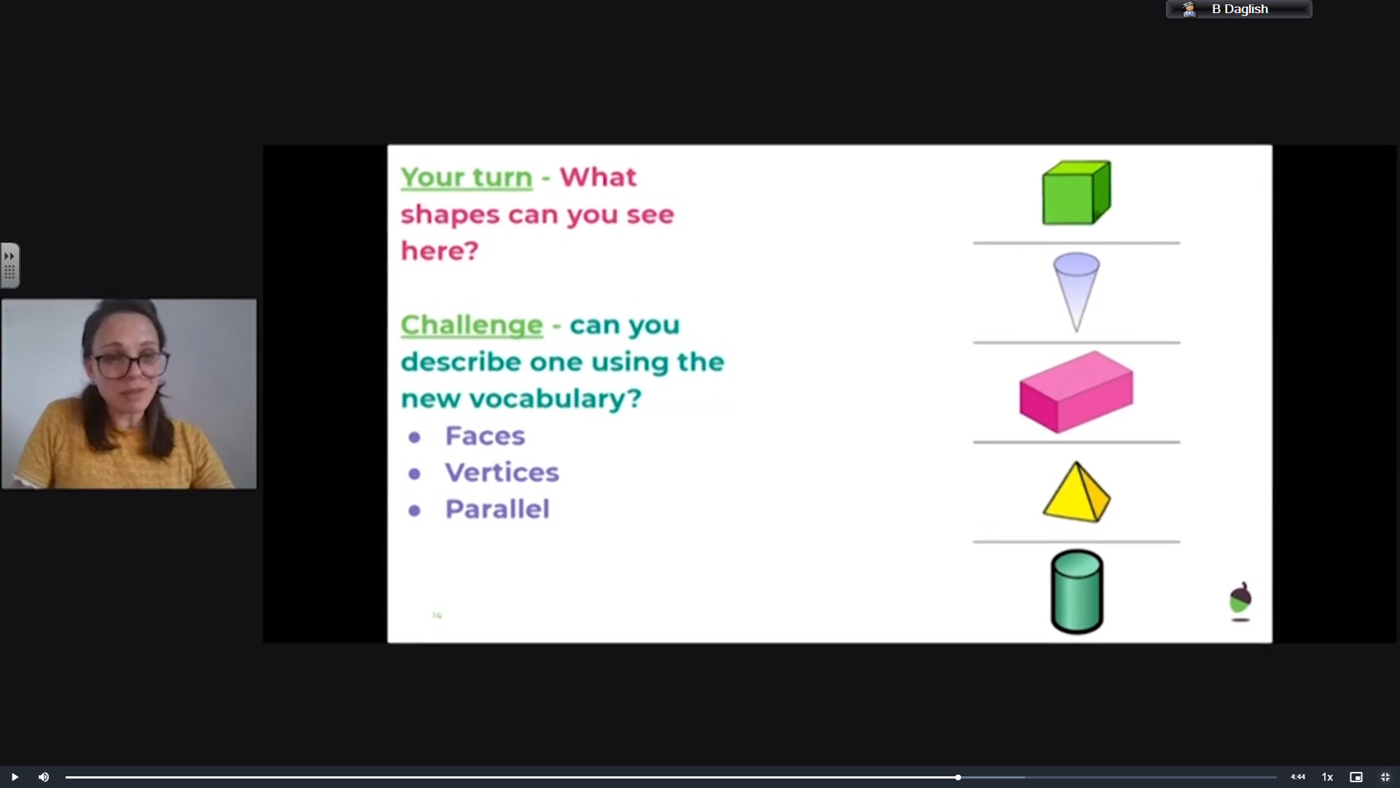

Shape =

Shape =

Shape =

Shape =

Shape =

Challenge – can you describe ONE of these shapes using some of the new vocabulary?

Faces, vertices or Parallel

__________________________________________________________________________________

__________________________________________________________________________________

__________________________________________________________________________________

Main Activity:

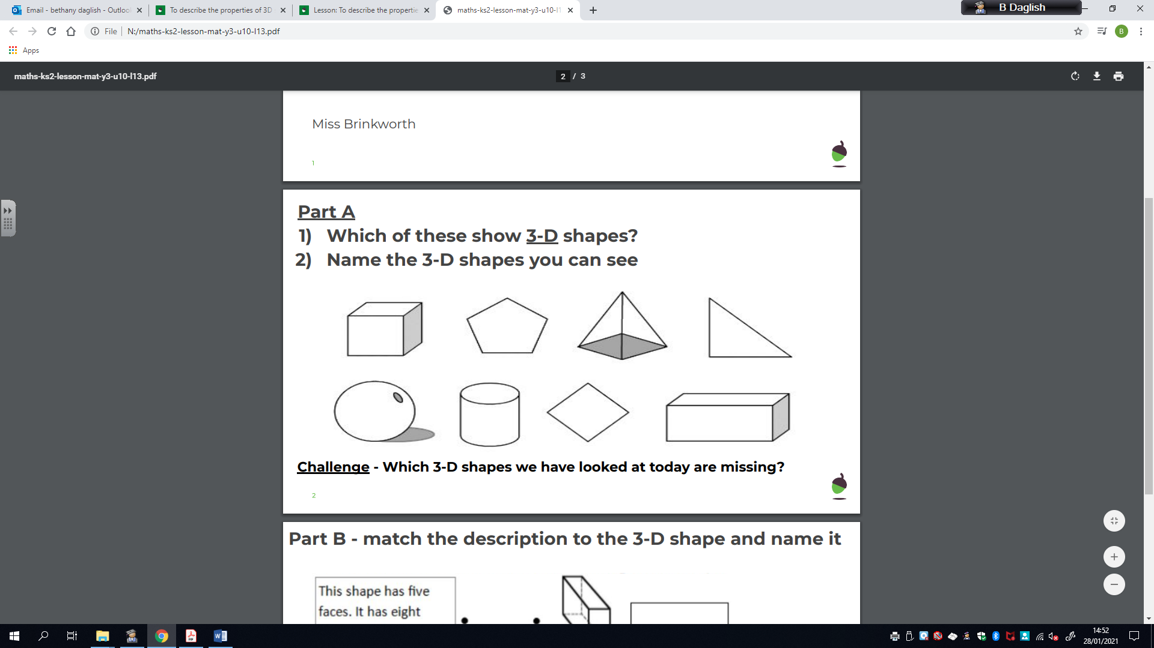

__________________________________________________________________________________

__________________________________________________________________________________

__________________________________________________________________________________

__________________________________________________________________________________

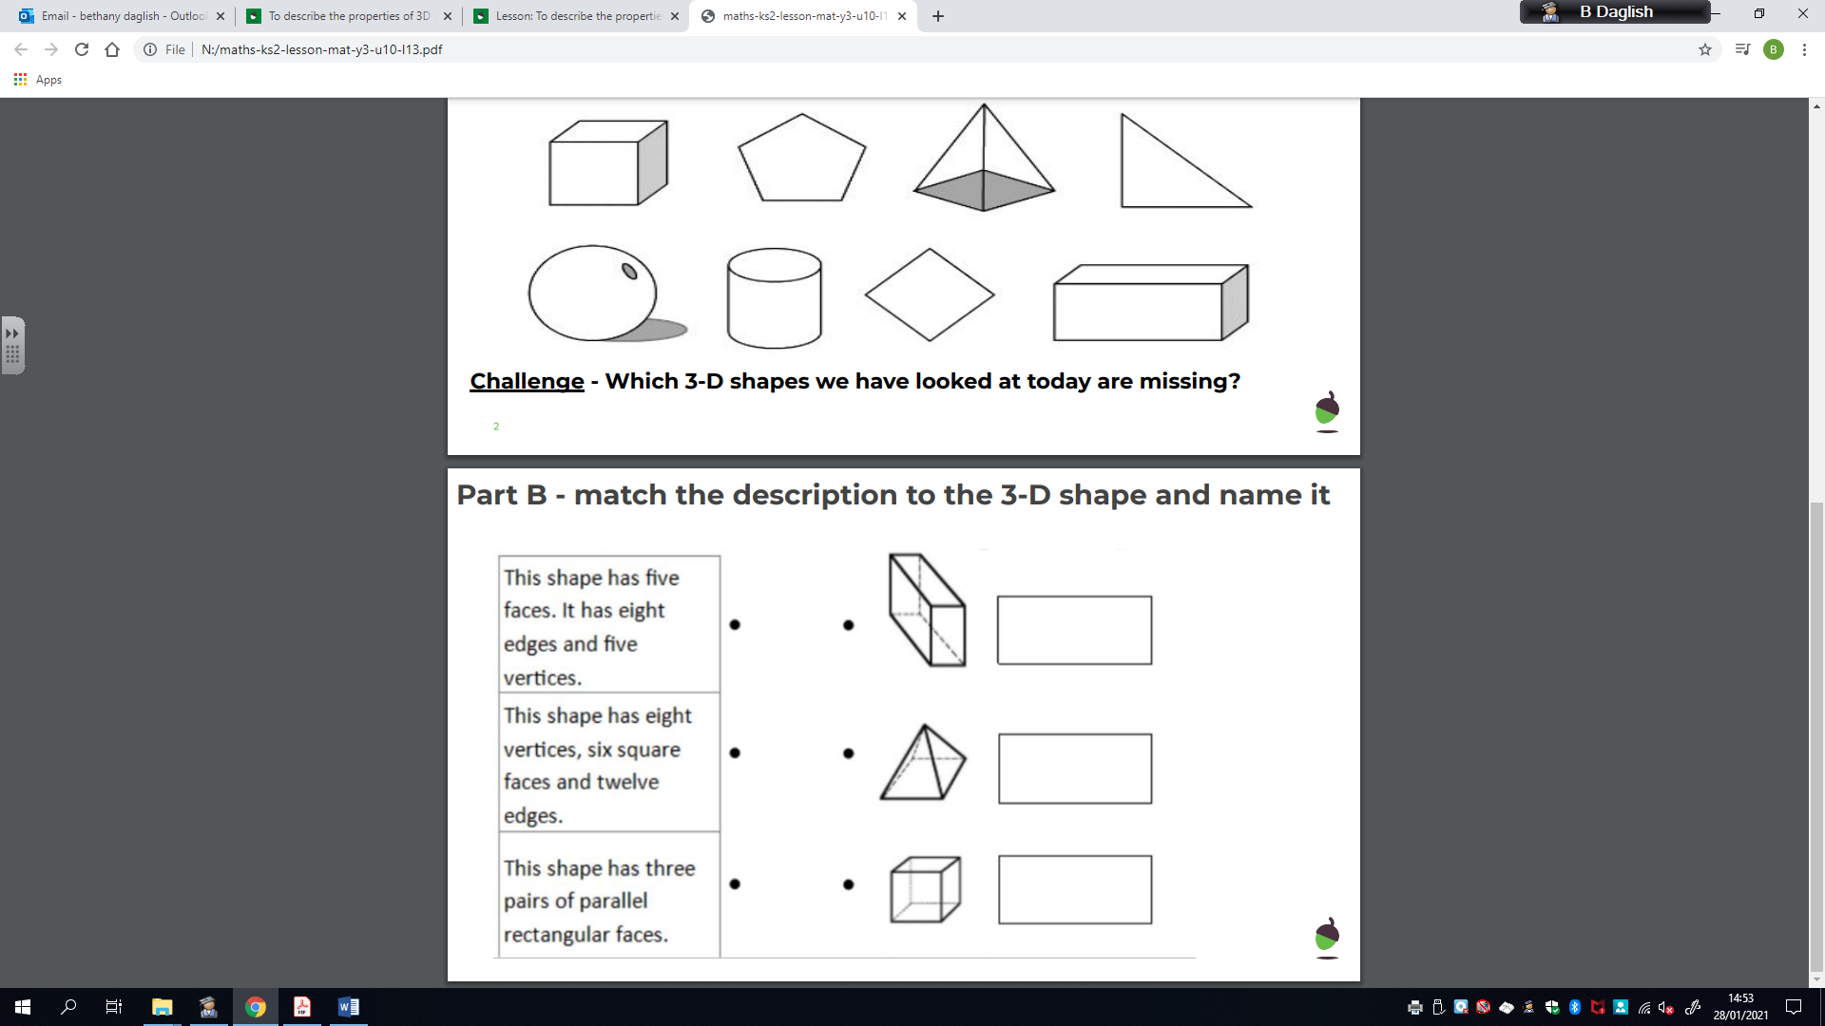

Complete the knowledge quiz at the end of the video clip on Oak Academy.