SCREEEN FREE FRIDAY ACTIVITIES:

Activity 1: Monopoly
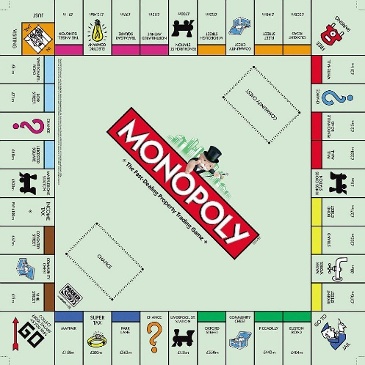
Create your own Monopoly board.

This could be local places in Borehamwood, or indeed London.

Think of 22 different places. They could be well know destinations such as Parkside Community Primary School, Tesco’s or Grandma’s house!

You will also need to make-
- Property Cards
- Money
- Community Chest and Chance cards
- Colouring pencils

Activity 2: Home Olympics
Discuss what the Olympics is.

What sort of activities might you be expecting to find?

Draw the logo of the Olympics.
What do the colours stand for?

The colours represent at least one colour from every flag that takes part in the Olympics.

Create a homemade event for the Olympics - can you find household items to make it more fun?
How good are you at throwing scrunched up paper into pans?
What about the straw javelin?
Roll up socks to make bowls!

Can you beat your score?

