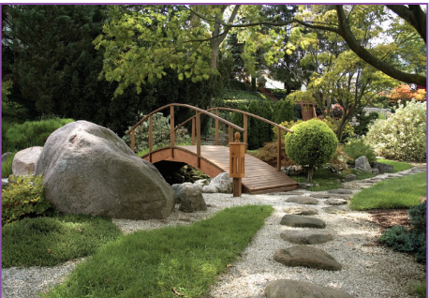

**Your challenge is to work with a partner/adult to make an imaginary bird for ‘A Garden of Dreams and Goals’. You must work cooperatively to create an imaginary dream bird that might live in the garden of dreams and goals. You can use a range of materials to construct your dream bird.**

**This is a garden of dreams and goals you can use your imagination. It is a happy, safe garden with nothing scary in it.**