**Sort these pictures into Human and Physical features of St Lucia**

[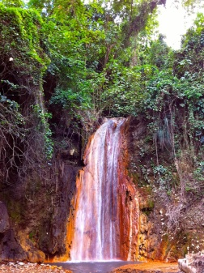](http://www.google.co.uk/url?sa=i&rct=j&q=&esrc=s&source=images&cd=&cad=rja&uact=8&ved=0ahUKEwiWgo2Wkc_SAhVpAcAKHYdhAy8QjRwIBw&url=http://www.wondermondo.com/Countries/NA/LesserAntilles/SaintLucia/DiamondFalls.htm&bvm=bv.149397726,d.ZGg&psig=AFQjCNED0X3lk3yZWhUbaFDkHOMGYSteVg&ust=1489345137270414)

[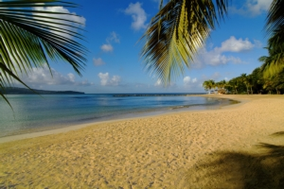](http://www.google.co.uk/url?sa=i&rct=j&q=&esrc=s&source=images&cd=&cad=rja&uact=8&ved=0ahUKEwjByanBkM_SAhVrCcAKHeuTBhcQjRwIBw&url=http://www.stluciasothebysrealty.com/section.asp?Sec%3D7%26SSec%3D7&bvm=bv.149397726,d.ZGg&psig=AFQjCNGwAJD2h20xQJM-TdrWhZvZVYf2lA&ust=1489344958491792)[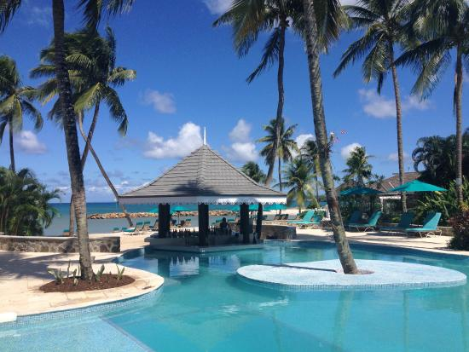](https://www.google.co.uk/url?sa=i&rct=j&q=&esrc=s&source=images&cd=&cad=rja&uact=8&ved=0ahUKEwjQxMnIks_SAhUJJcAKHZZGAjIQjRwIBw&url=https://www.tripadvisor.co.uk/Hotel_Review-g147343-d150434-Reviews-Rendezvous_Resort-Castries_Castries_Quarter_St_Lucia.html&bvm=bv.149397726,d.ZGg&psig=AFQjCNECUbrfYLU6md5nC-QViffQ5vonpA&ust=1489345519461725)[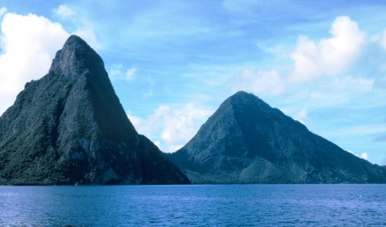](http://www.google.co.uk/url?sa=i&rct=j&q=&esrc=s&source=images&cd=&cad=rja&uact=8&ved=0ahUKEwiwnLjmkM_SAhXMA8AKHd3sCvkQjRwIBw&url=http://www.rainforestadventure.com/st-lucia/natural-attractions/the-pitons/&bvm=bv.149397726,d.ZGg&psig=AFQjCNHohYRzkYo3HyNjeZij_TgwwYHqiQ&ust=1489345034278732)[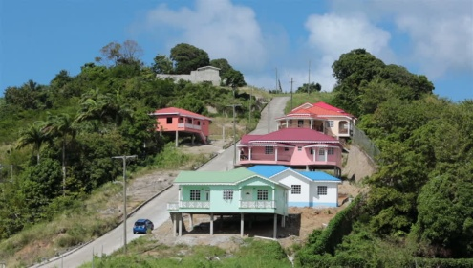](http://www.google.co.uk/url?sa=i&rct=j&q=&esrc=s&source=images&cd=&cad=rja&uact=8&ved=0ahUKEwiY_8rsks_SAhXKDsAKHTioDcgQjRwIBw&url=http://www.shutterstock.com/video/clip-4808060-stock-footage-st-lucia-house.html&bvm=bv.149397726,d.ZGg&psig=AFQjCNEFnS_VnZbOn_1FvSKDdfV54J6arA&ust=1489345589209303)[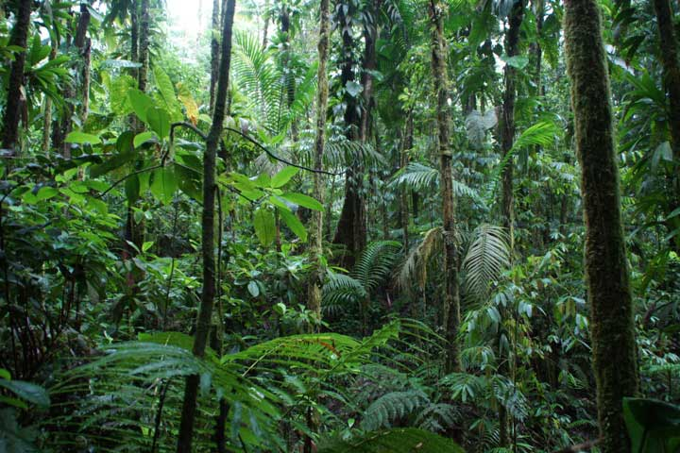](http://www.google.co.uk/url?sa=i&rct=j&q=&esrc=s&source=images&cd=&cad=rja&uact=8&ved=0ahUKEwjuq7rIk8_SAhUXOsAKHQuvCPYQjRwIBw&url=http://www.balenbouche.com/st-lucia-hiking/&bvm=bv.149397726,d.ZGg&psig=AFQjCNHcpA3TMIeC2m5_a8jD7Gf1xt4rXA&ust=1489345738555312)[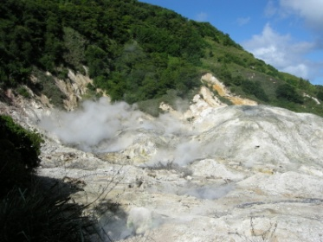](https://www.google.co.uk/url?sa=i&rct=j&q=&esrc=s&source=images&cd=&cad=rja&uact=8&ved=0ahUKEwiq4bOKkM_SAhVKB8AKHYxmArQQjRwIBw&url=https://carolynsshadegardens.com/tag/sulphur-springs-st-lucia/&bvm=bv.149397726,d.ZGg&psig=AFQjCNGKtDYCJIZAPynz9VSNoAaau4y3kw&ust=1489344842029283)[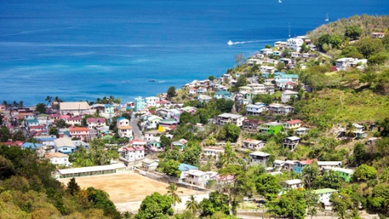](http://www.google.co.uk/url?sa=i&rct=j&q=&esrc=s&source=images&cd=&cad=rja&uact=8&ved=0ahUKEwjuvpWAks_SAhXJLsAKHSP9C1cQjRwIBw&url=http://www.thomson.co.uk/cruise/caribbean/castries-port/&bvm=bv.149397726,d.ZGg&psig=AFQjCNH7wWop-QLPDhoNptTMWkHPU8zgMw&ust=1489345363682393)[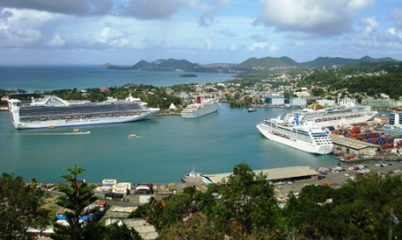](https://www.google.co.uk/url?sa=i&rct=j&q=&esrc=s&source=images&cd=&cad=rja&uact=8&ved=0ahUKEwjA_OrMkc_SAhVrJcAKHb-pDKwQjRwIBw&url=https://www.stlucianewsonline.com/saint-lucia-has-lost-its-competitiveness-in-the-cruise-industry-says-minister/&bvm=bv.149397726,d.ZGg&psig=AFQjCNGetCd3IpKqkKvpPA-M_hpF-1Fndw&ust=1489345253313700)

Castries - Capital City

Diamond Falls Waterfall

Beaches

Rainforest

Hotel Resort

Pitons - mountains

Houses

Castries Harbour

Sulphur Springs

Volcano