Indoor Scavenger Hunt!

How many of these things can you find? Good luck!
- Find a fork
- Find something that is red
- Find a tissue box
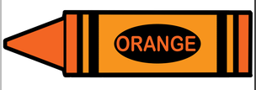
- Find 3 things that have wheels
- Find an orange crayon or felt tip or pencil crayon
- Find something that is very soft
- Find a plaster
- Find a key
- Find 2 socks that match
- Find something round
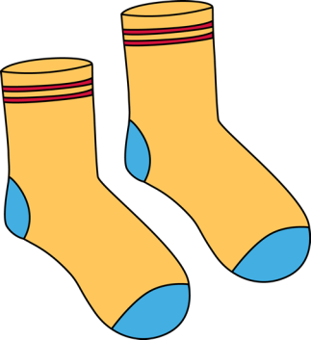
- Find a sticker
- Find a rubber band
- Find a of pair of gloves
- Find an envelope
- Find something that you can eat.

