**Is It Fair?**

Read these examples and talk about whether what happens is fair or not fair. Sort them into two sections and write an explanation.

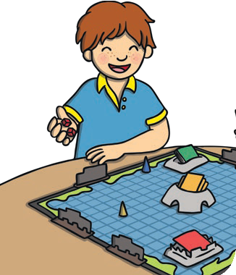

1. A boy cheats

in a game.

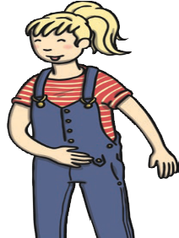

2. A girl is told off for talking but it wasn’t her fault.

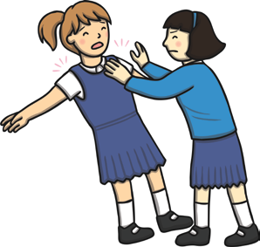

3. A girl pushes another girl out of the dinner queue.

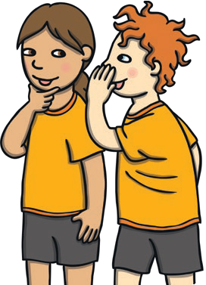

4. A girl tells a lie that gets another girl into trouble.

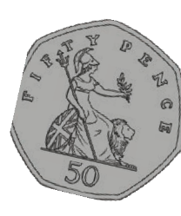

A boy finds some money and hands it in. The shopkeeper says the boy can keep the 50p.



A girl at the party doesn’t have much food so the teacher gives her a bigger slice.