Tuesday 5th January 2021.
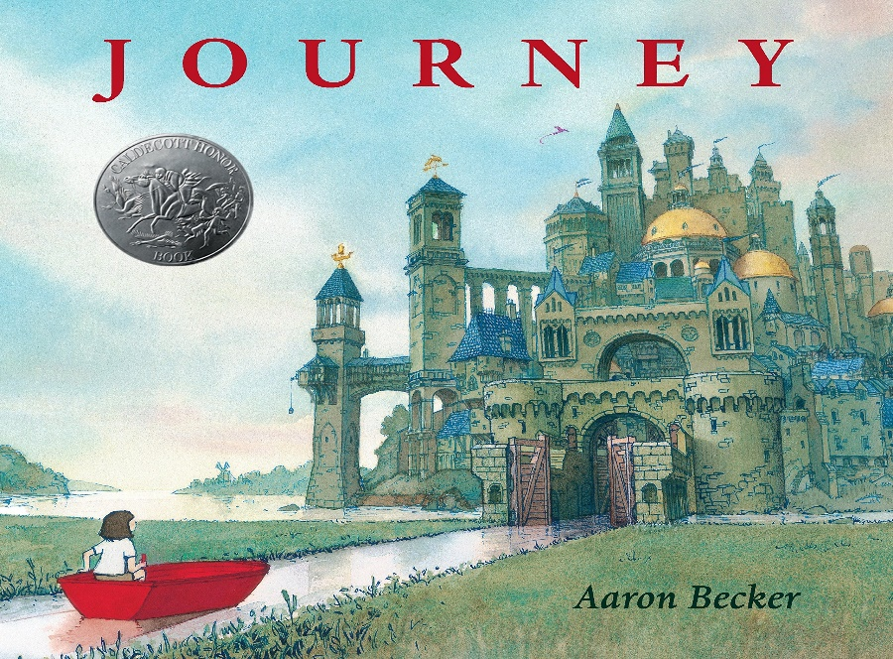
LO: Can I make predictions about a text?

This is the book we are going to be focusing on over the next few weeks.

What sort of book might this be? What sort of journey might the character be making?
What do you think might happen?
Do you have any questions about this image?
Complete the grid, writing down your ideas about the front cover and what may happen in the story.

Use the sentence starters to help you.

Observe: | I can see  There is  There are
Wonder: | I wonder why …?  I wonder where …?  I wonder how …?  I wonder if …?
Infer: | I think …. because ….  The reason for ….

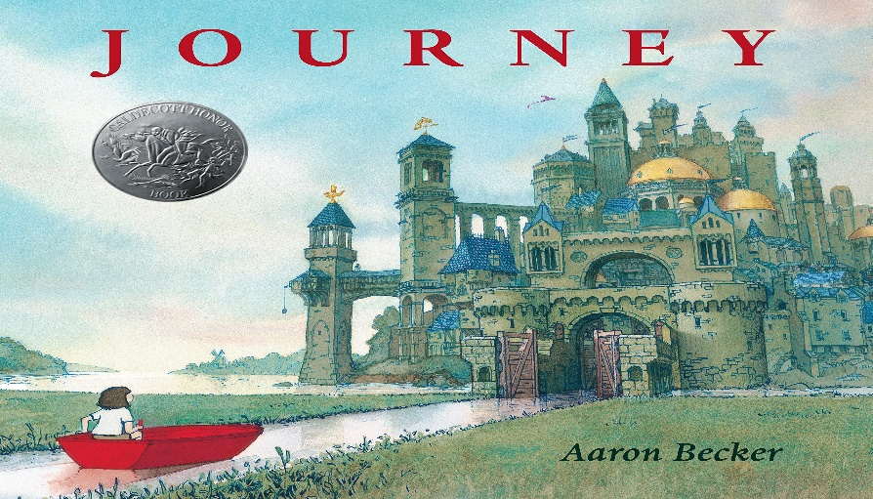 | Observe
Wonder | Infer

