What was the first thing you saw?
What noises might the stream make?
How could you describe the trees?
How could you describe the light?

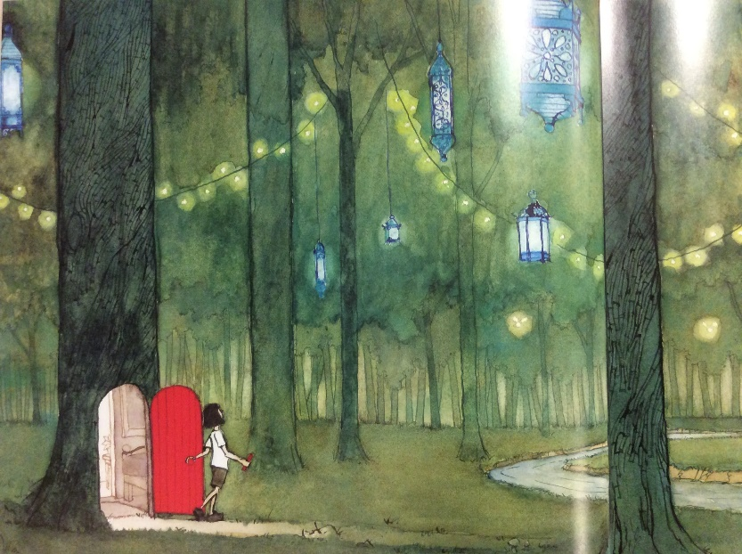
Answer the questions above and write about the picture.

As I walked through the door __________________________________________________________
__________________________________________________________________________________
__________________________________________________________________________________
__________________________________________________________________________________
__________________________________________________________________________________
__________________________________________________________________________________
__________________________________________________________________________________
__________________________________________________________________________________
__________________________________________________________________________________
__________________________________________________________________________________
__________________________________________________________________________________
__________________________________________________________________________________
__________________________________________________________________________________
__________________________________________________________________________________
__________________________________________________________________________________

