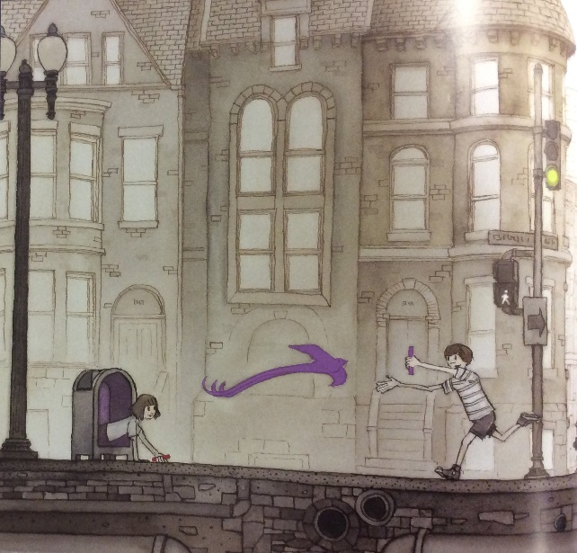
At the end of the story, the girl meets a boy.
Write questions that you would ask the boy if you were the girl.
Remember to use a question mark at the end of each sentence.
?

What ----------------------------------------------------------------------------------------------------------------------------

Why-------------------------------------------------------------------------------------------------------------------------------

How -------------------------------------------------------------------------------------------------------------------------------
--------------------------------------------------------------------------------------------------------------------------------------

When -----------------------------------------------------------------------------------------------------------------------------
-------------------------------------------------------------------------------------------------------------------------------------

------------------------------------------------------------------------------------------------------------------------------
-------------------------------------------------------------------------------------------------------------------------------------

