SCREEEN FREE FRIDAY ACTIVITIES:

Activity 1: Paper Aeroplane Contest

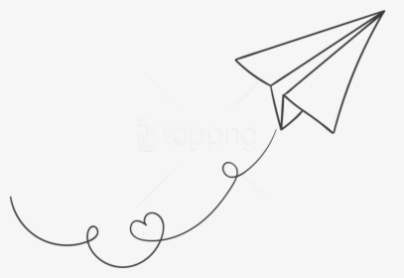
Who can fly their paper airplane the furthest?

Discuss the following questions:
Do you think it matters on size?
Do you think it matters on the material you use?
Do you think it matters if you attach other paper to it?

Make a paper airplane, test it out safely then see if you can improve it anyway, can anything change to make it go further?

Challenge someone in your house to beat you!

If you have a story book or information book about Amy Johnson or planes, build a reading den and have a read, or sit in your favourite place.

If you don’t have any books about planes, choose your favourite book to read instead.
Ask a grown up what they know about Amy Johnson!

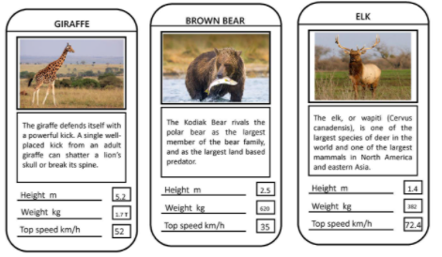
Activity 2: Top Trumps

Can you create your own set of 24 top trumps? It could be anything you like! Cartoons, cars, footballers, favourite films!

Once you have created your 24, challenge a group of friends and then test each other out!

Activity 3: Reading Den!

If you have a story book or information (non fiction) book, build a reading den or sit in your favourite place and have a read.

If you’re feeling creative, grab your colouring pencils and draw a picture from your book.

