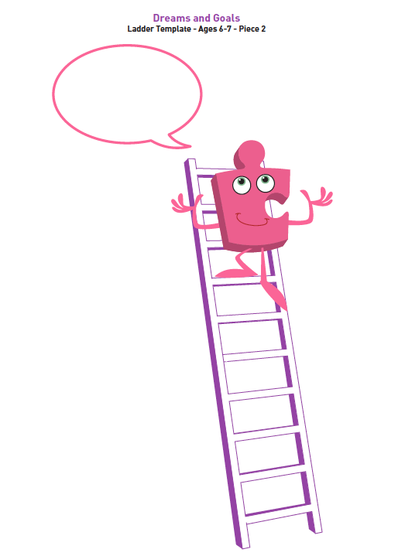

Task: Next to each rung on the ladder write down a step that will help you to achieve your learning goal.

In the speech bubble write down your learning goal.