**Monday 1st February 2021**



**LO: Can I revisit parallel and perpendicular lines?**

Warm up Task:

Match the angels to their definitions. Use an arrow to do this. The first one has been done for you as an example.

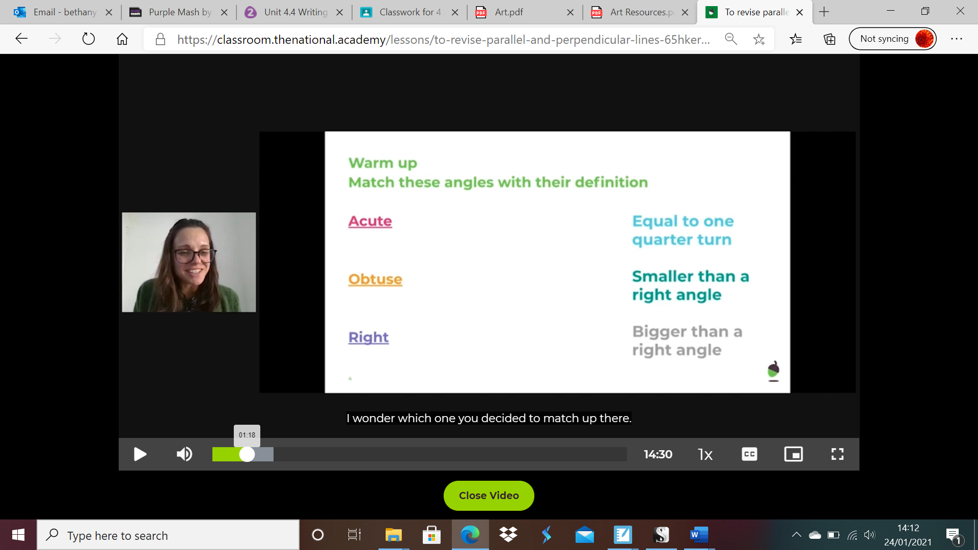

To complete the tasks coming up, you can use the PEN option. If you don’t see the DRAW tab at the top of the page (this will sit between ‘insert’ and ‘design’) then follow the steps below to add it:

1. From the top of Microsoft Word, click **File**, then **Options**.
2. Click the **Customize Ribbon** tab, click the check box labelled **Draw**, then click **OK**.

This will be very helpful as you can mark the page with ticks of circle your answers then save.

Task One:

Find the perpendicular lines below:

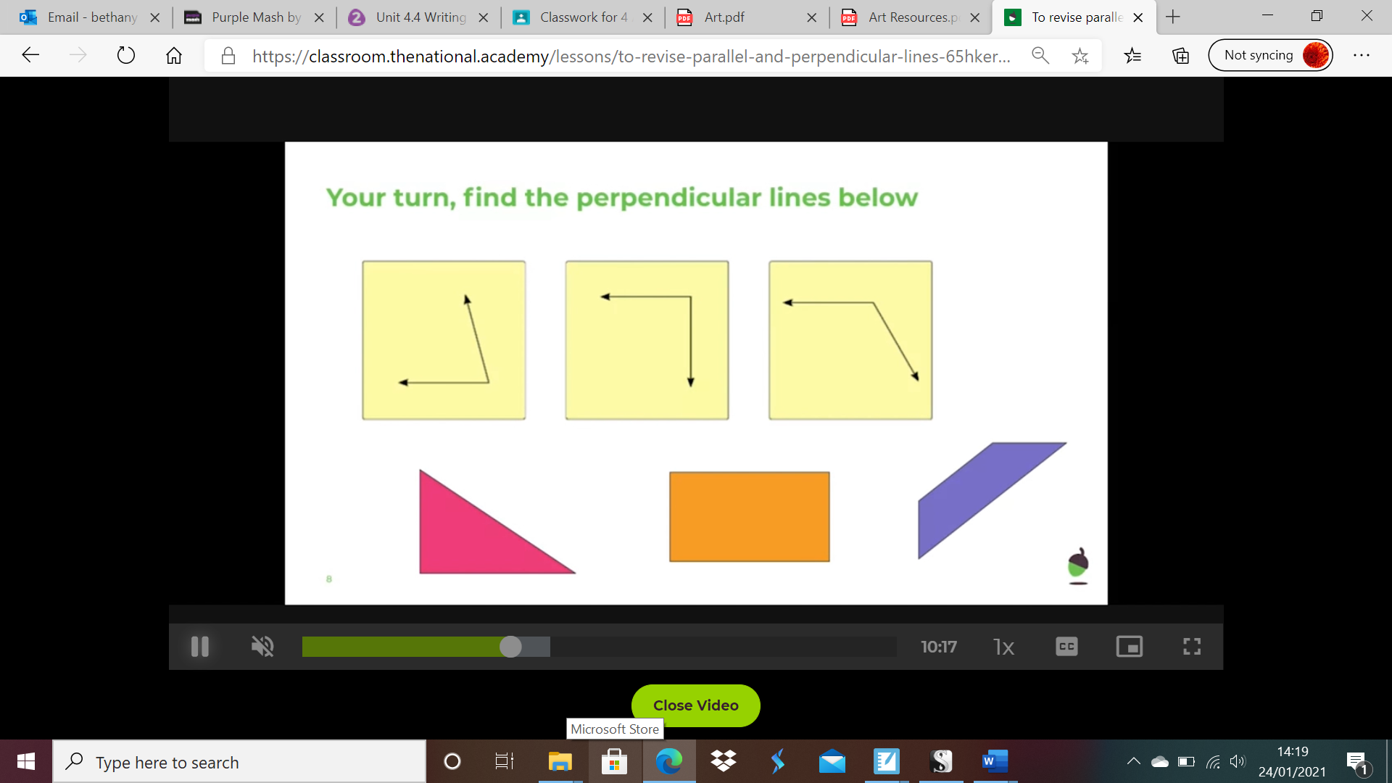

Task Two:

Find the parallel lines below:

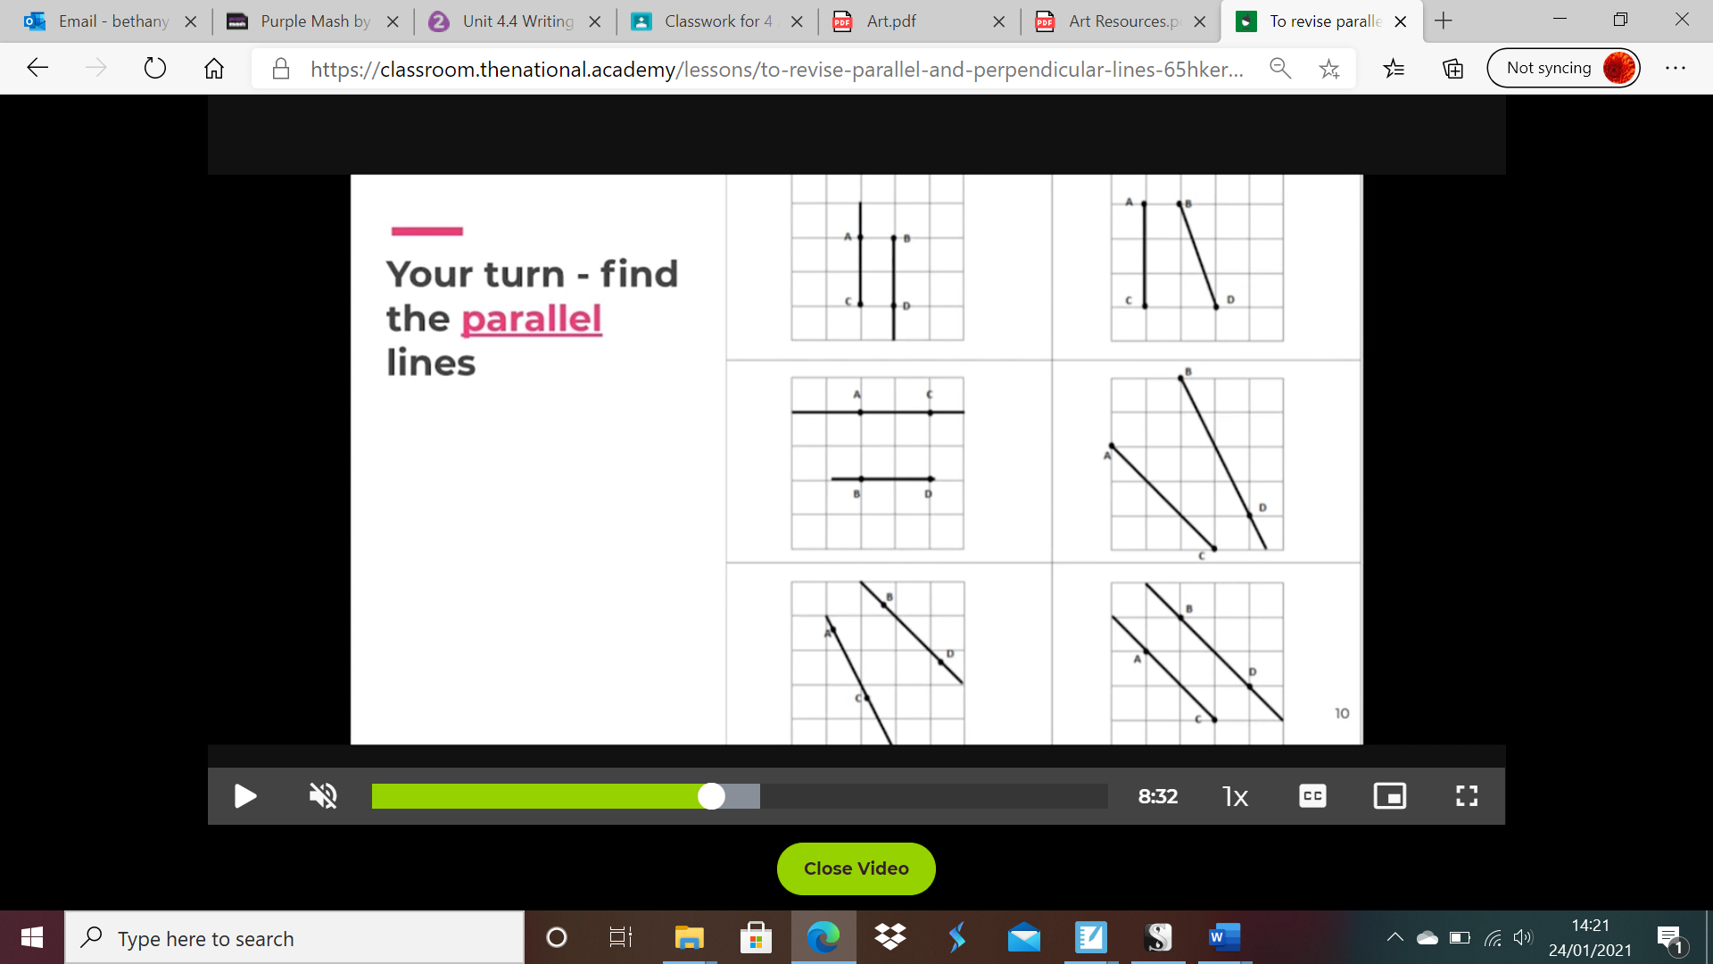

Task Three:

Find the parallel and perpendicular lines below (hint: there are two of each):

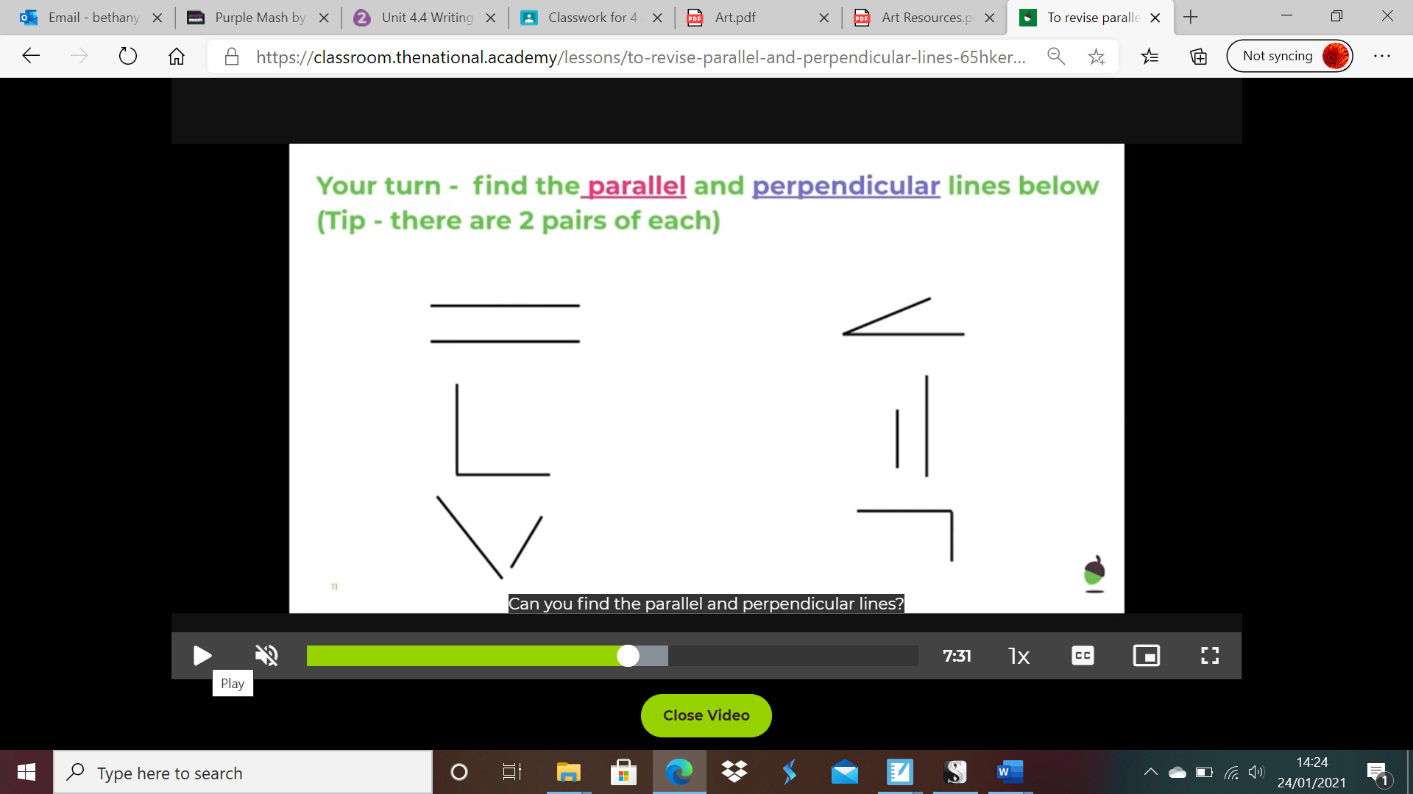

Task Four:

Find the parallel and perpendicular lines below:

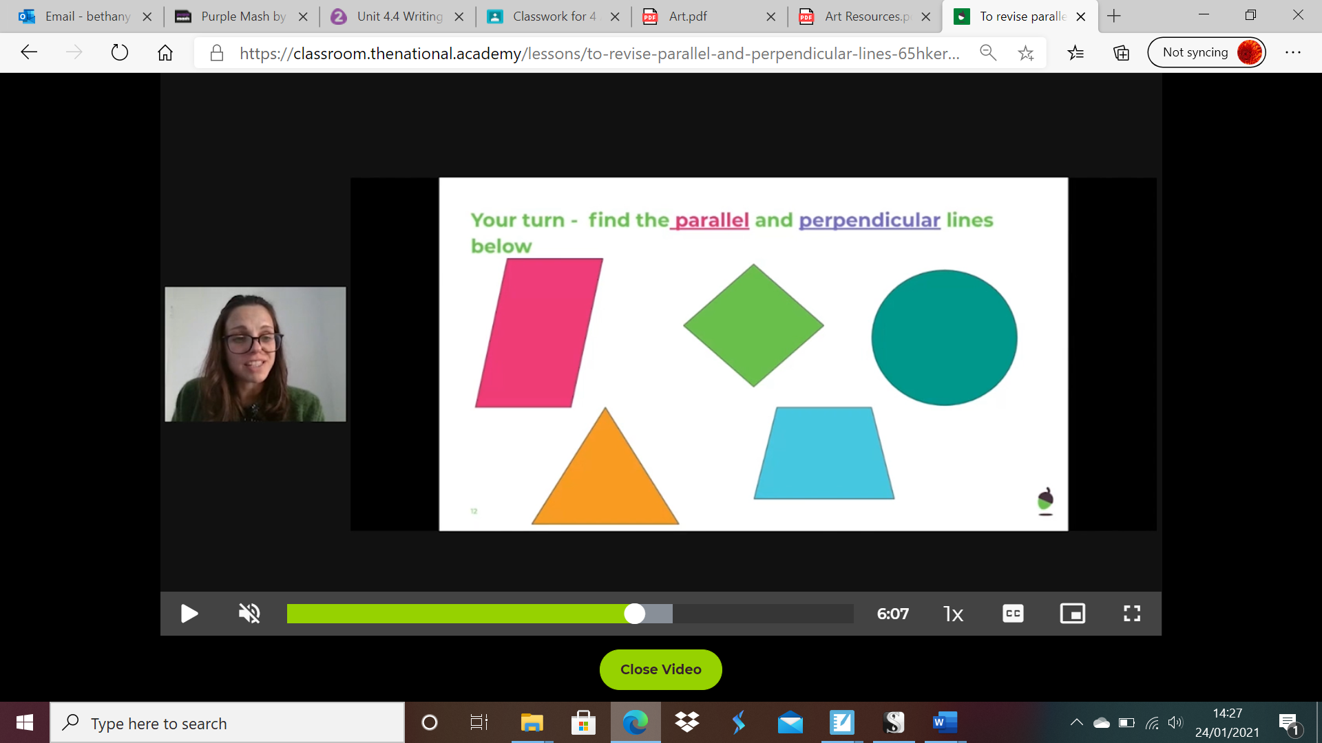

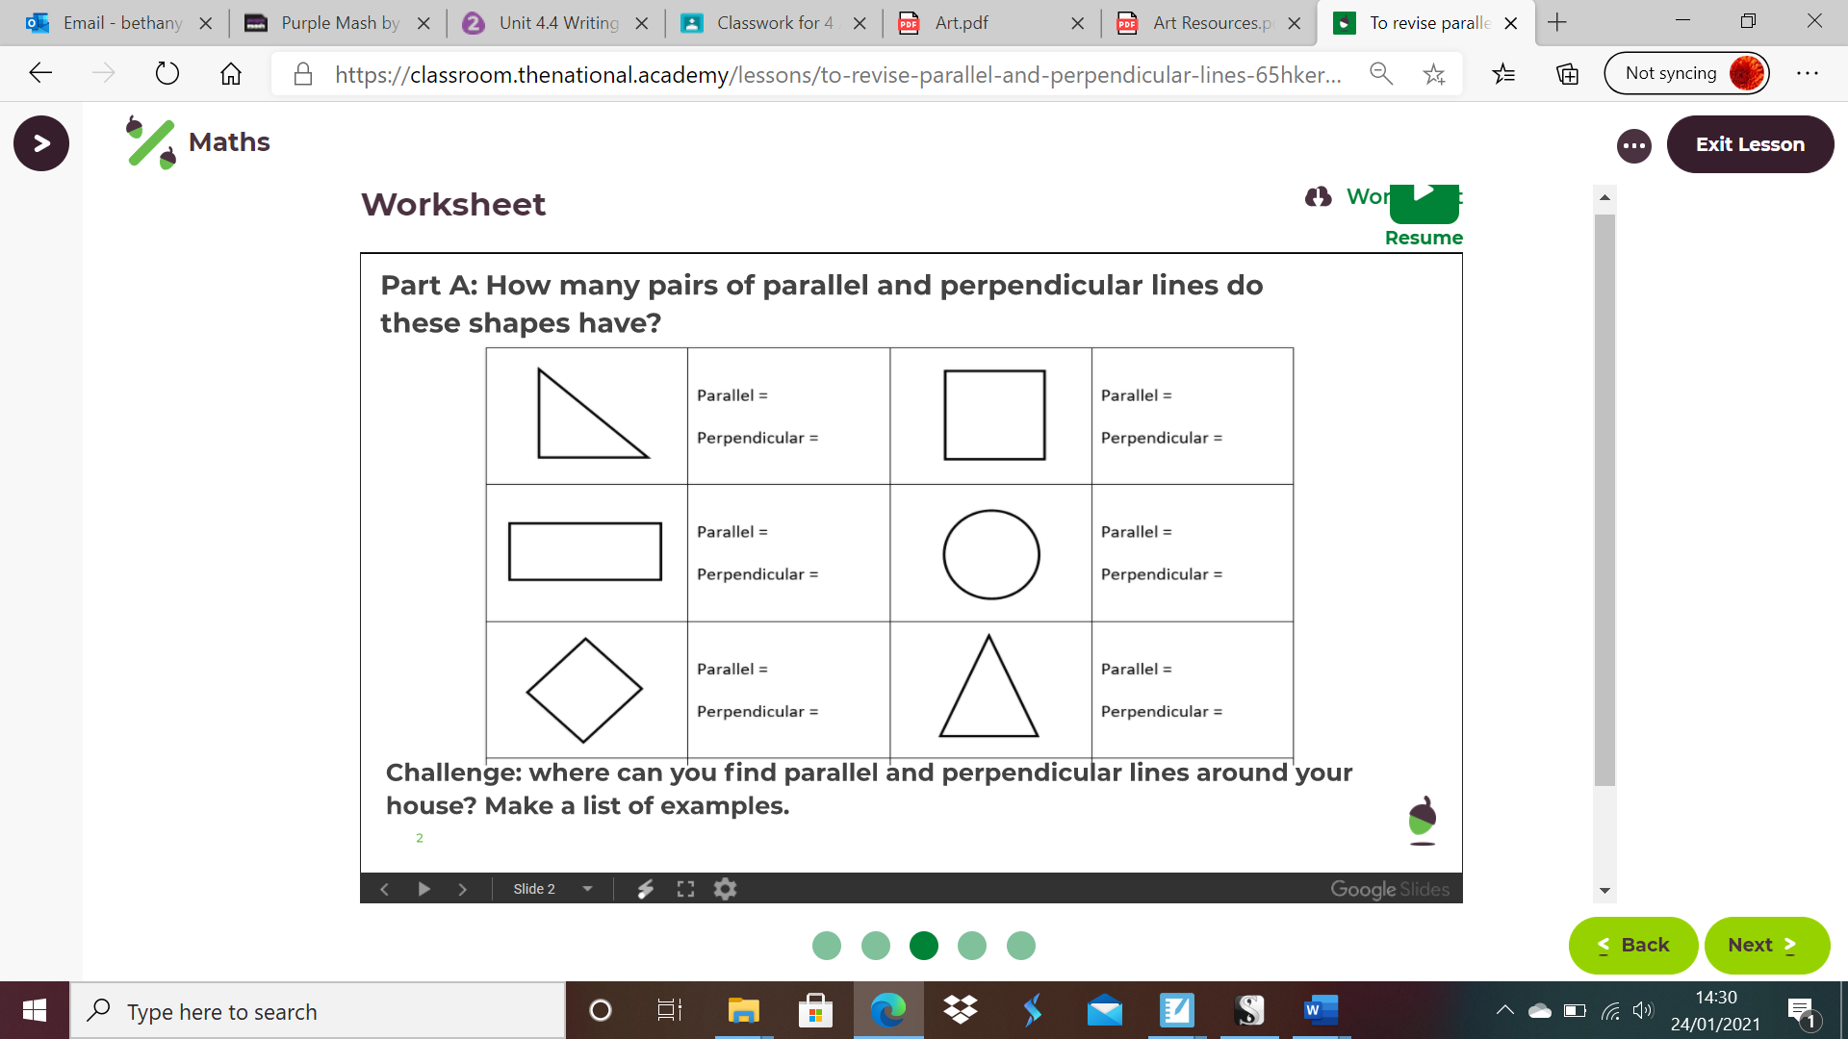Main Activity:

Type here…

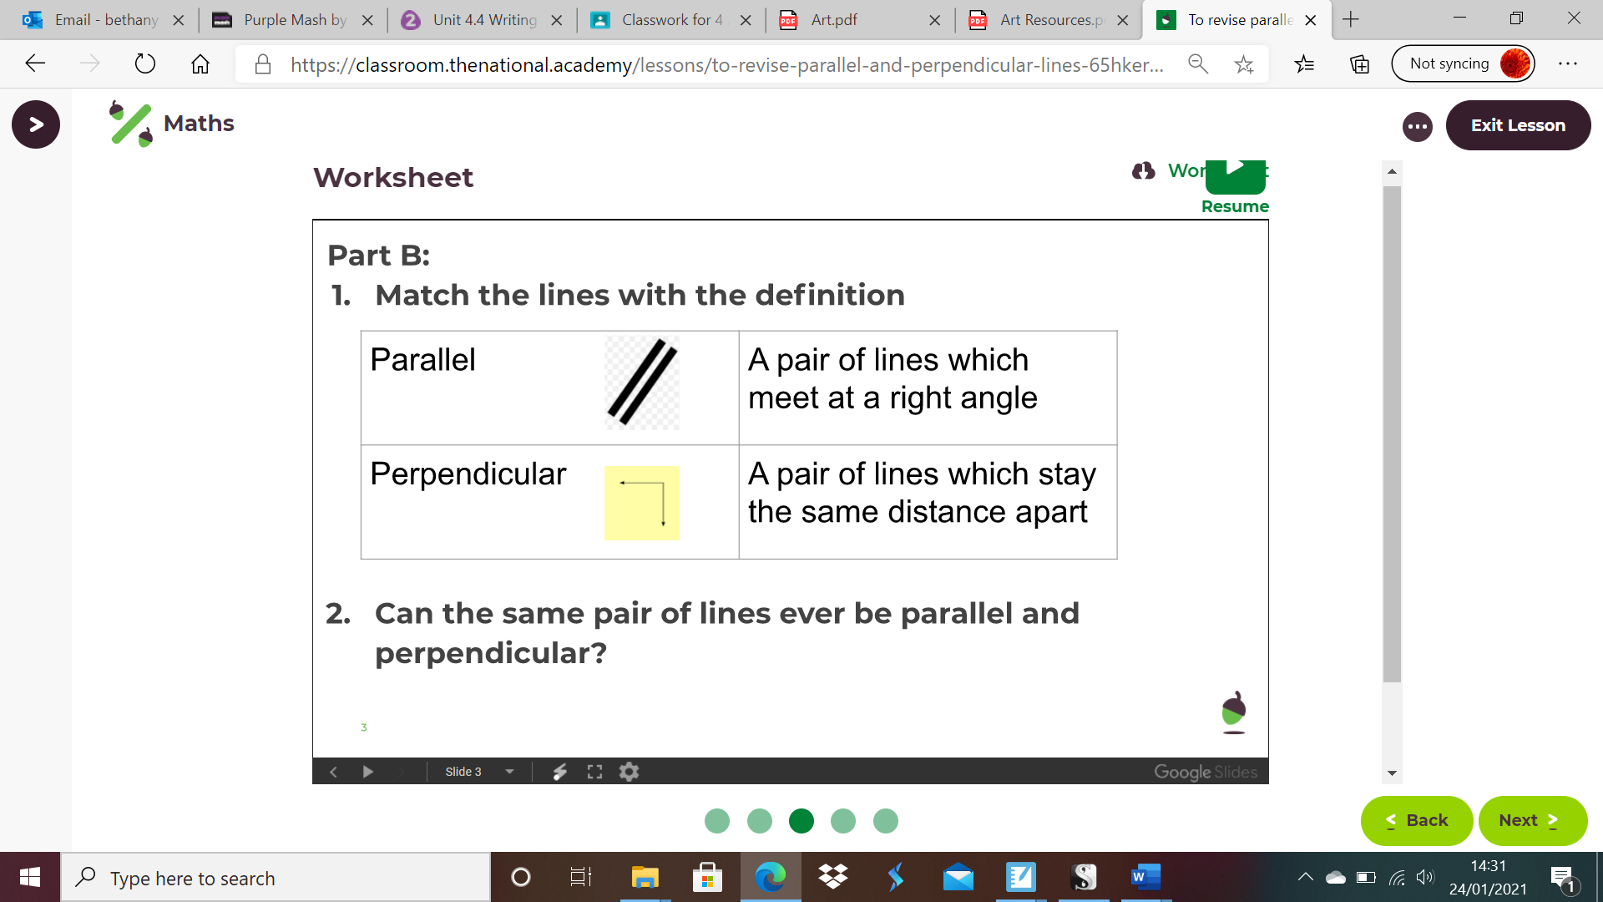

Type here…

Complete the knowledge quiz at the end of the video clip on Oak Academy.