Knowledge Organiser (Rivers)
Key Vocabulary | Definition
source | The start of the river, usually on high ground.
stream | A narrow river
tributaries | A stream or lots of streams that merge into a river.
estuary | The area where a river meets the sea.
mouth of a river | The end of a river, where the sea begins.
river basin/drainage basin | The area of land from which water has drained into a river.
watershed | The edge of a river basin.
waterway | A route within a river that is used for travel.

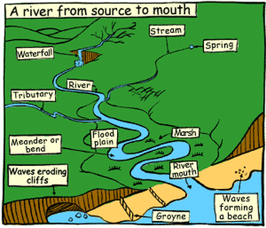

River Thames | River Danube | River Nile | The Ganges | The Amazon | The Murray
Europe | Europe | Africa | Asia | South America | Australia
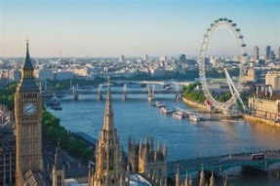 | 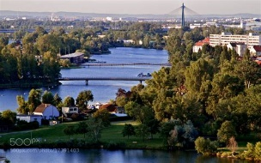 | 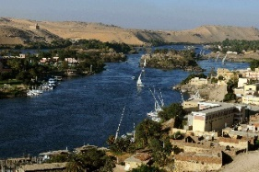 | 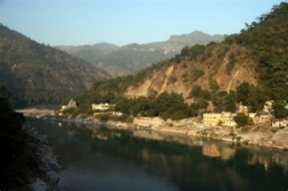 | 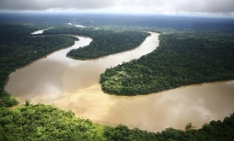 | 