Knowledge Organiser - Mythological Paintings
Key Vocabulary | Definition
Myth | A traditional story made up in the past, often to explain an event, belief or custom
Mythological paintings | Paintings relating to or based on myths
Classical | Something that is from ancient Greek or Roman culture
Narrative | A piece of art that tells a story with colour and lines, instead of words
Character | A person or an animal in a piece of narrative art
Characteristic | An important thing about thing or a person which makes them what they are
setting | The place where a story takes place
Minotaur | A monster which is half bull and half man
Art | Artist/Title
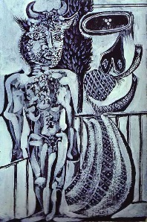 | Pablo Picasso, Minotaur and his Wife, 1937
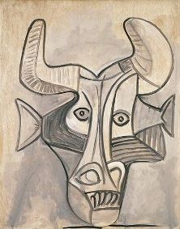 | Pablo Picasso, Minotaur, 1933
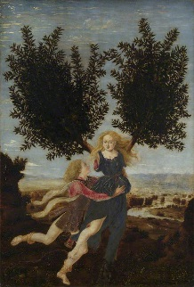 | Antonio del Pollaiuolo, Apollo and Daphne, (c.1432-1498)

