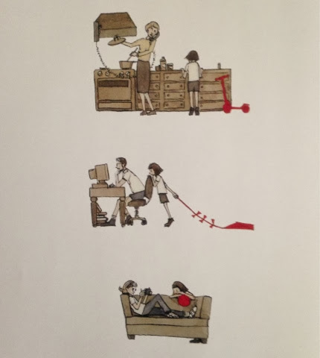  See  What can you see?  I can see a little girl who is trying to play with her------------- and ---------------  No one is ___________________________________________________________________________ |  | 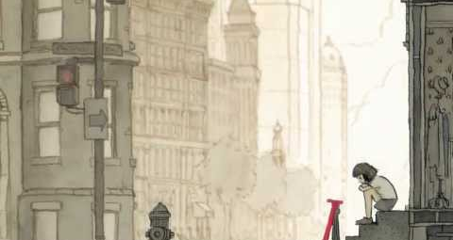  Think  What do you think she would like to do?  How is she feeling in this picture?  She looks lonely, so I think she would like to _______________________________________
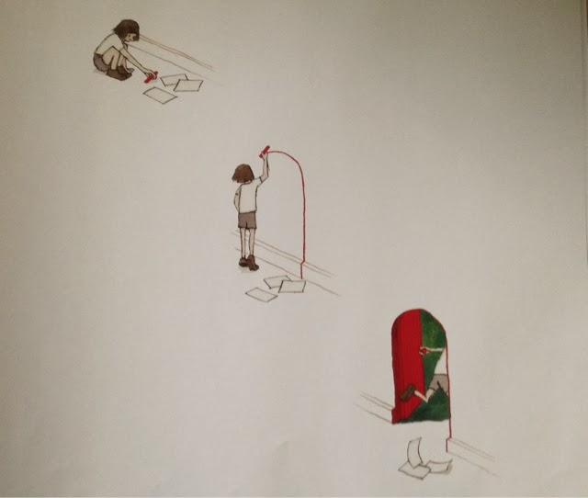
Why?

Why does she want to leave?

Why is she lonely?

She wants to leave to be noticed and feel loved. She would like to go to _______

