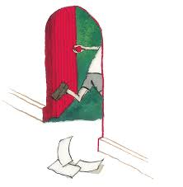

If you could draw a door like the girl in the story, where would you like to end up?

Farm
Choose one setting to write about:
Jungle

Park
ZZZZZZ
ZZZ

Write about what you can: see hear
I walk through the door and find myself in a -------------------------------------------------------------

