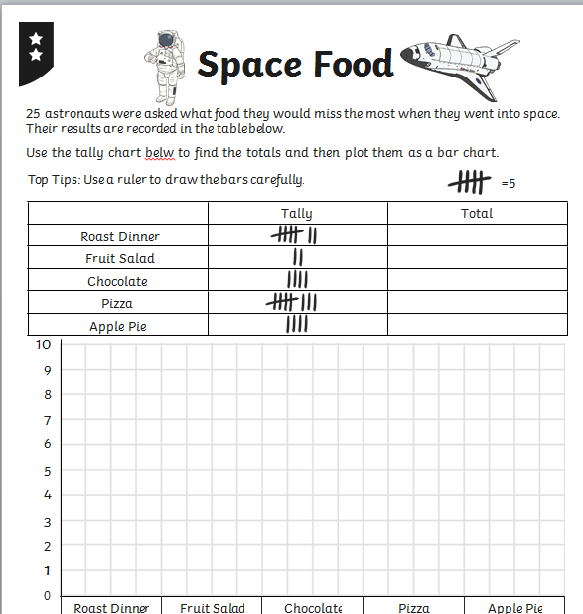
Friday 8th January 2021

What food was missed the most?

How many people liked pizza?

How food was missed least?

What is the difference between chocolate and apple pie?

How many missed chocolate and fruit salad?

