Friday 8th January 2021.
LO: Can I use expanded noun phrases in my writing?

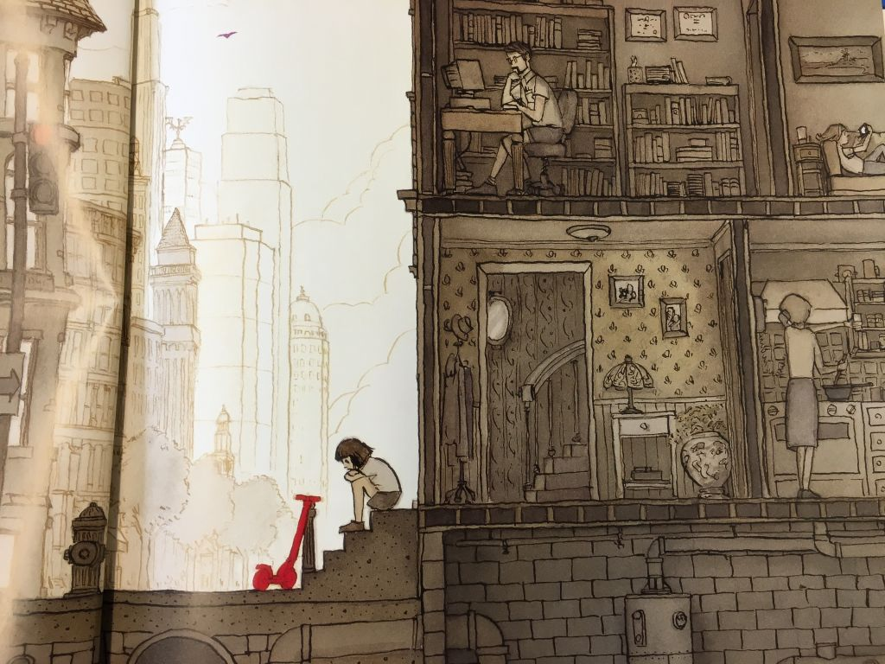
Using your phrases that you wrote yesterday, can you write a paragraph to describe this image?

Success Criteria:
- Use the 5 senses
- Use 1 or 2 adjectives (don’t forget the comma)
- Challenge: can you include extra details in your expanded noun phrases?

For example:
Feeling lonely, a young girl sits on the steep, stone steps. In front of the young girl, there is a small, red scooter propped up against a bollard.

