**Name of River:**

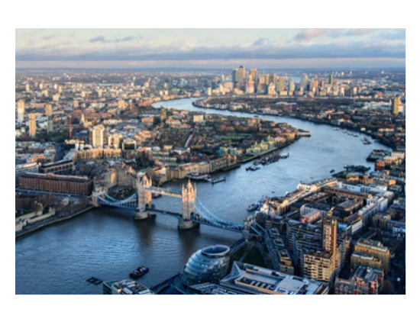

Source of River:

___________________________________________________________________________________________________

Mouth of River:

___________________________________________________________________________________________________

What countries/cities does the river flow through:

_______________________________________________________________________________________________________________________________________________________________________________________________________________________________________

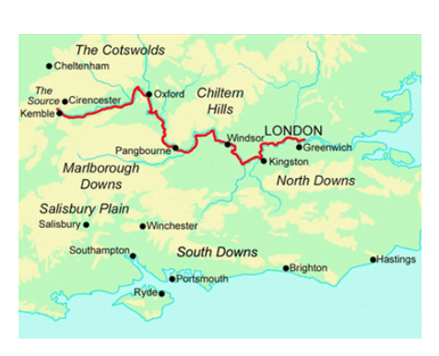

Did you know?

___________________________________________________________________________________________________

Important Landmarks found along the river:

____________________________________________________________________________________________________________________________________________________________________________________________________________________________________________________________________________________________________________________________________________________________________________________________________________________________________________________________

Three important facts about the river:

________________________________________________________________________________________________________________________________________________________________________________________________________________________________________________________________________________________________________