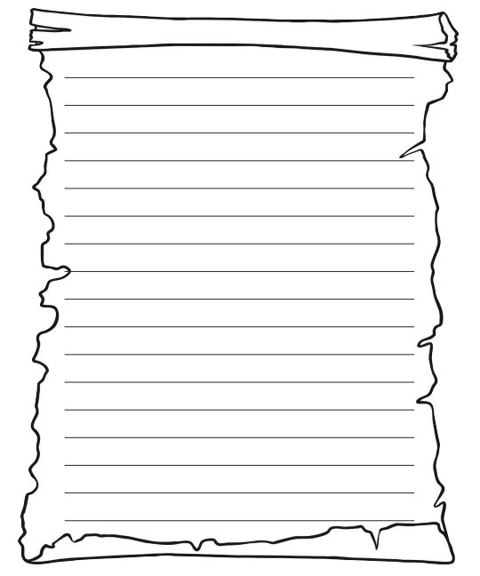

Thursday 21st January 2021

Task: Write a dairy entry about your day