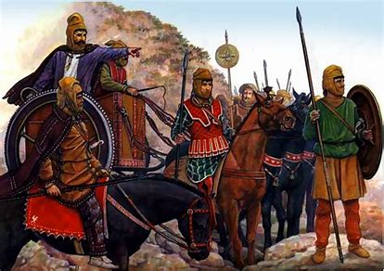

His men:

His men:

King Darius:

King Darius:

His men:

King Darius: