Can I evaluate my work?

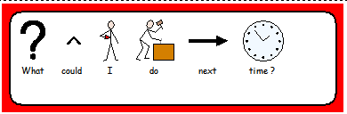

Did I include the following?
- painted brick exterior
- 4 rooms separated with card
- furniture in each room

