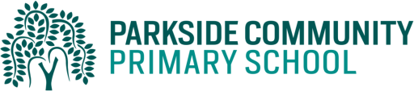
Dear Parents/Carers,
As part of our standards cup, children will help their class to earn points by completing their homework. The best way to help their class earn the points is to do their daily reading. Children must read to an adult and have their reading records signed daily. In addition, children can select from a variety of other activities from the table below. Homework should be completed and recorded by the children themselves with some support if needed.
These activities will be due by the 11th December. The children are expected to complete at least 3 of these activities per half term but may complete more if they choose.
Children are also able to log into Education City and Purple Mash through their Wonde password on a daily basis.
Activity 1 (History)  Create a timeline of your life from when you were born to now including significant events in your life. You could include pictures and photos. | Activity 2 (Science)  Write instructions on how to look after a pet.
Activity 3 (Maths)  Login online and complete Purple mash activities online. | Activity 4 (English)  Login online and complete Education city activities online
Activity 5 (PE)  Make up your own dance about toys that come to life. | Activity 6 (DT)  Make a home for an animal using a shoe box. Make sure they have somewhere cosy to sleep, an eating area and a litter area.
Activity 7 (Science)  Create an animal welfare poster. | Activity 8 (PHSE)  Write a story about celebrating differences.
Activity 9 (RE)  Design a festive card.  Write about how your family celebrates the festive season. | Activity 10  An activity of your own choice
Thank you for supporting us with homework.
Kind Regards,
The Year 1 Team

