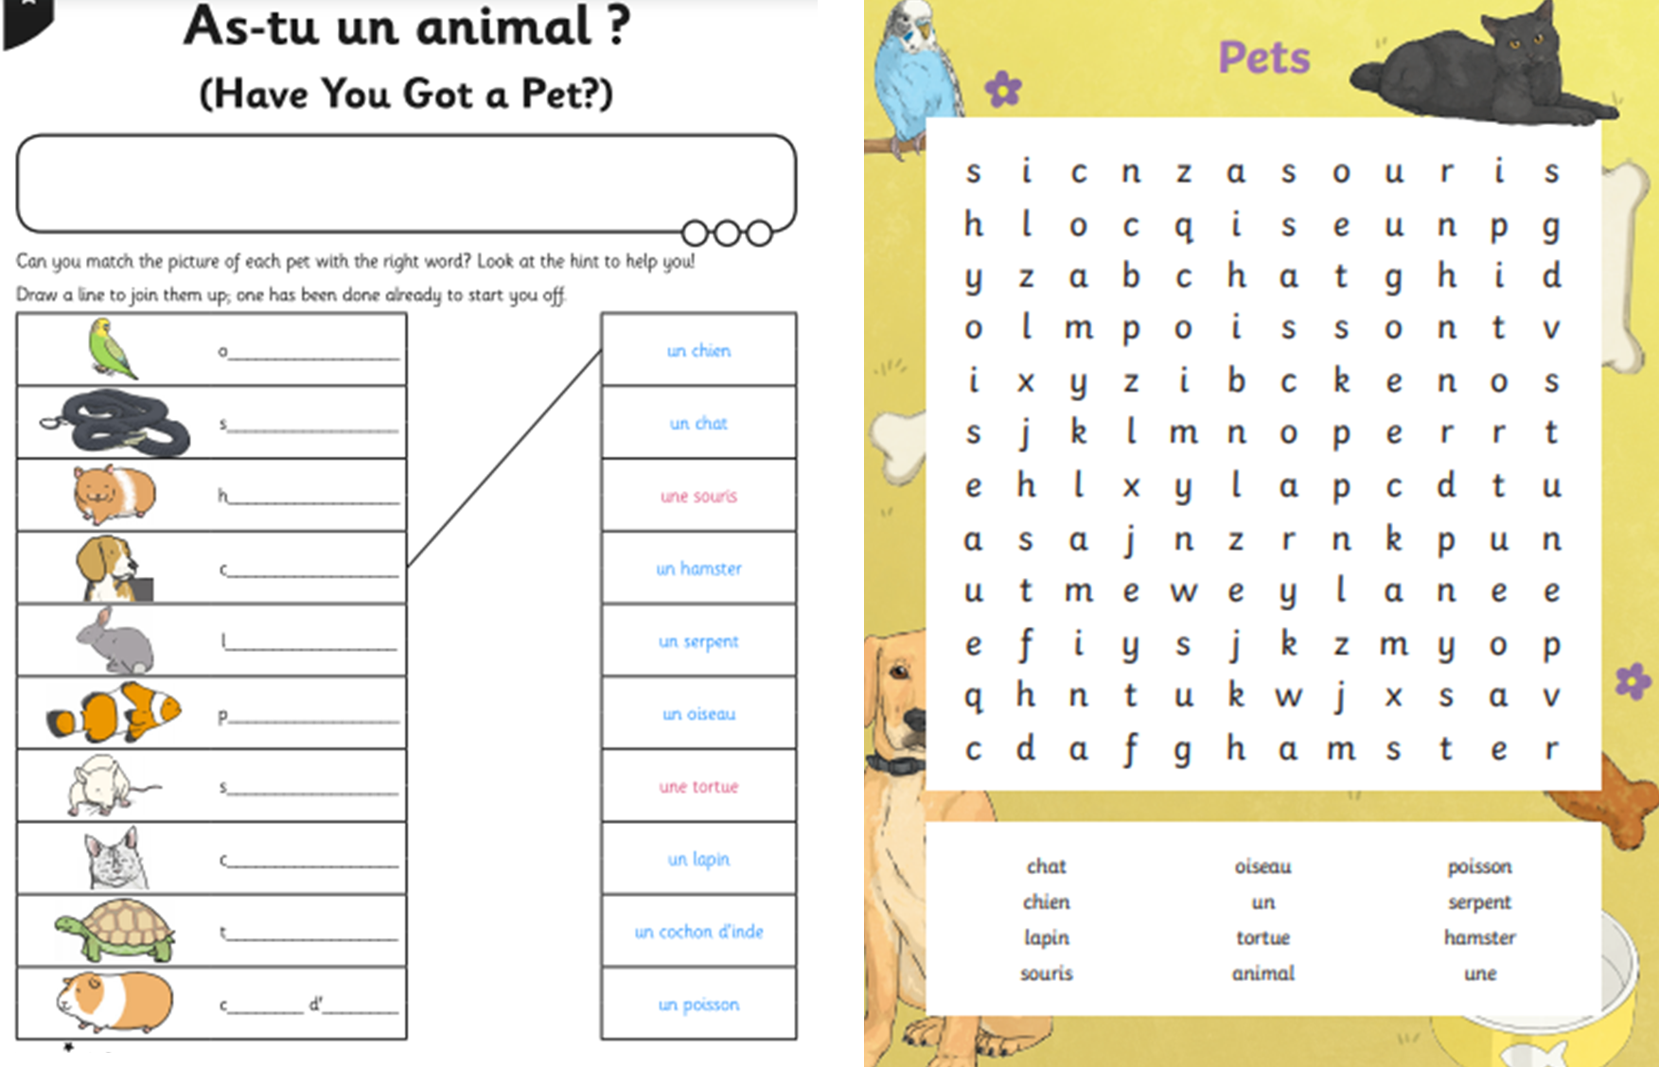

Match and write the animal names in French and then complete the wordsearch.