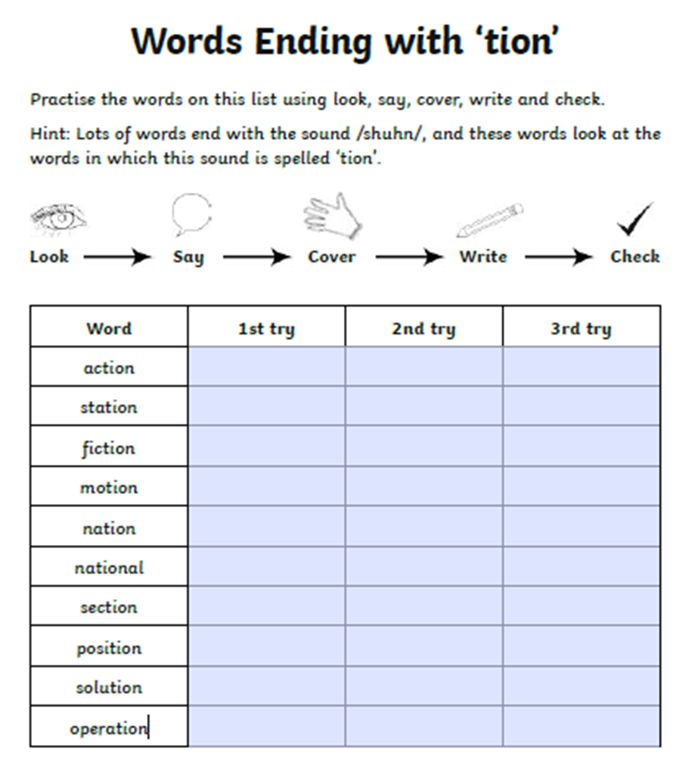

Practice your spellings using look, say, cover, write, check.