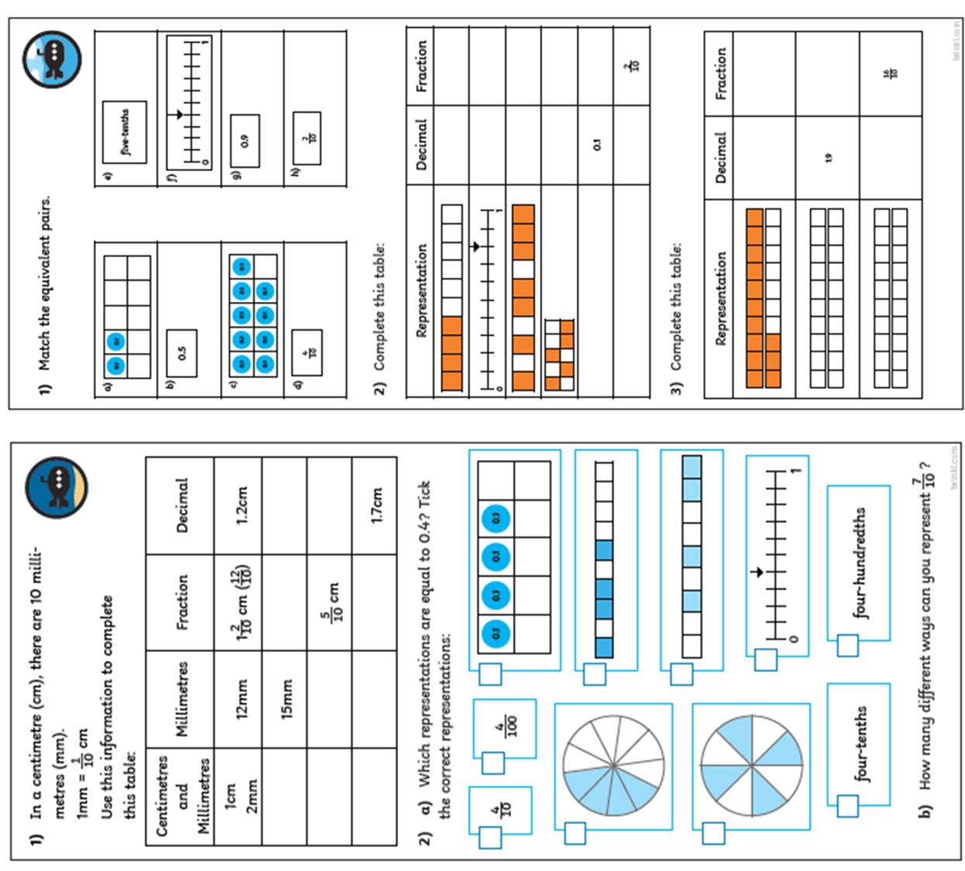

Challenge 3

Answer the decimal and fraction questions