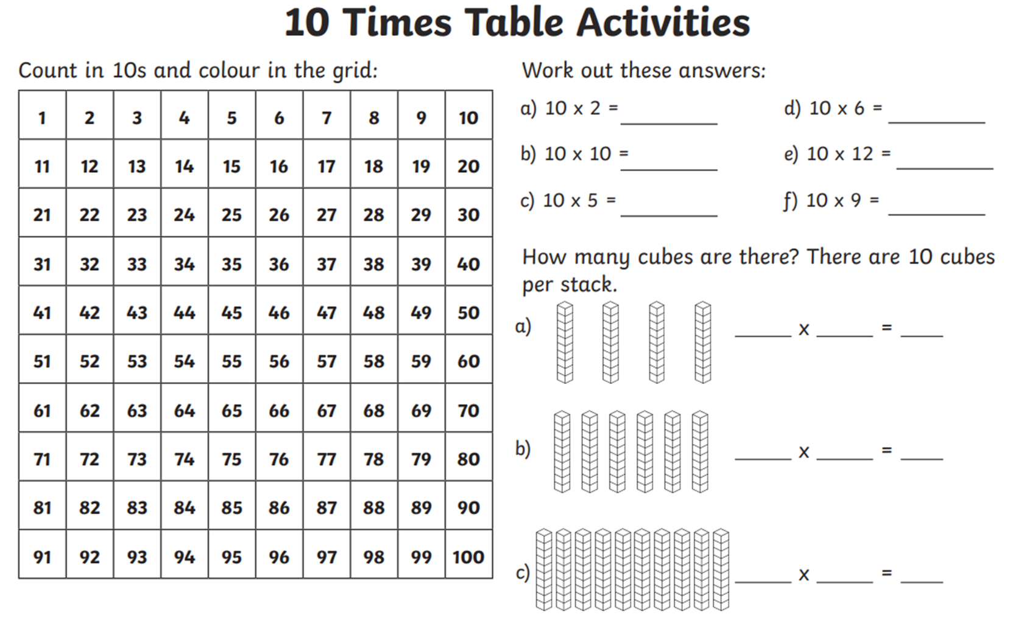

Challenge 1

Complete the 10 times tables questions.