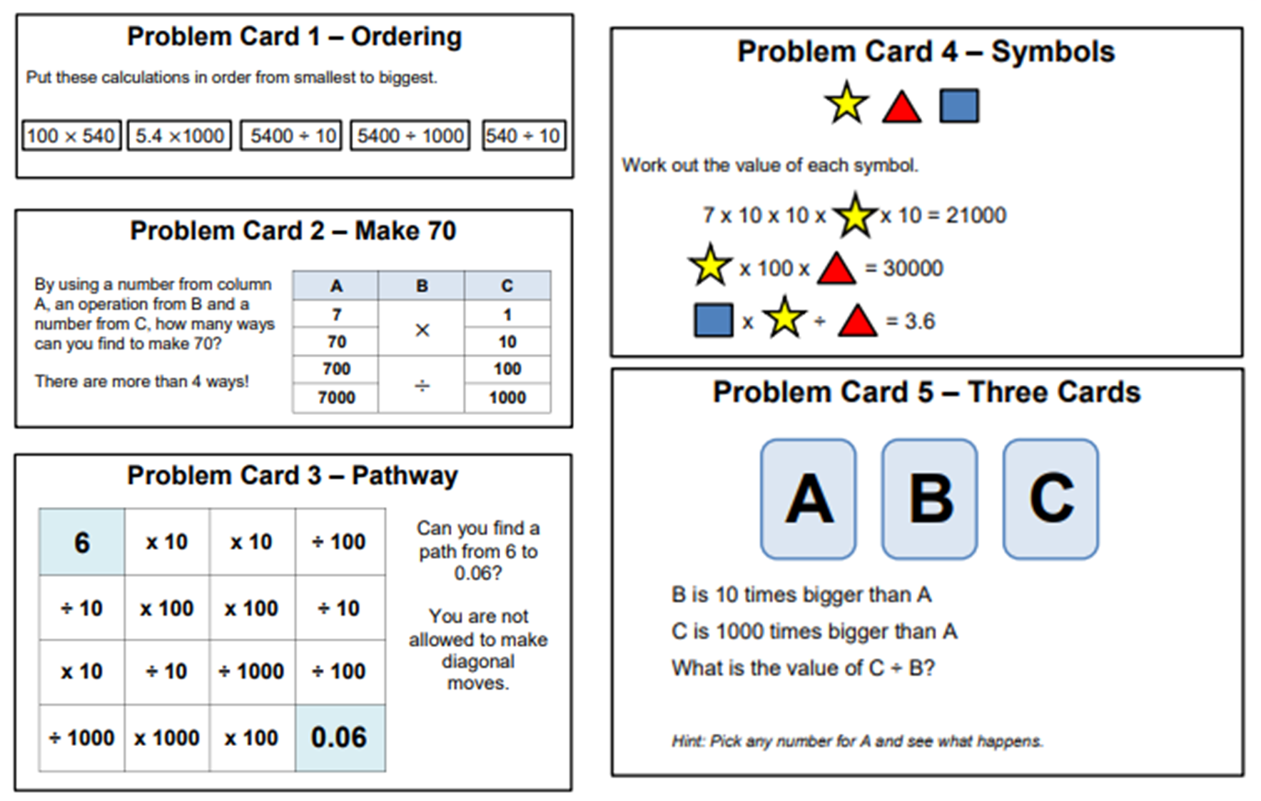

Challenge 3

Complete the problem cards.