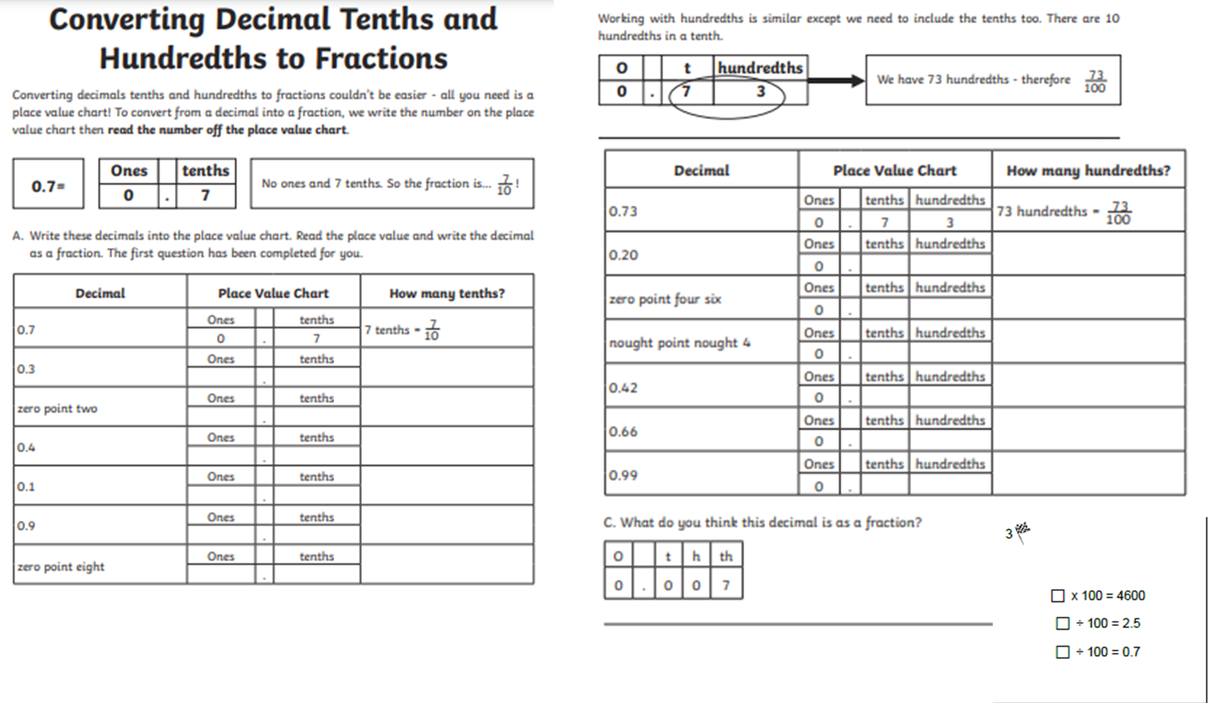

Challenge 2

Complete the tenths and hundredths to fractions questions.