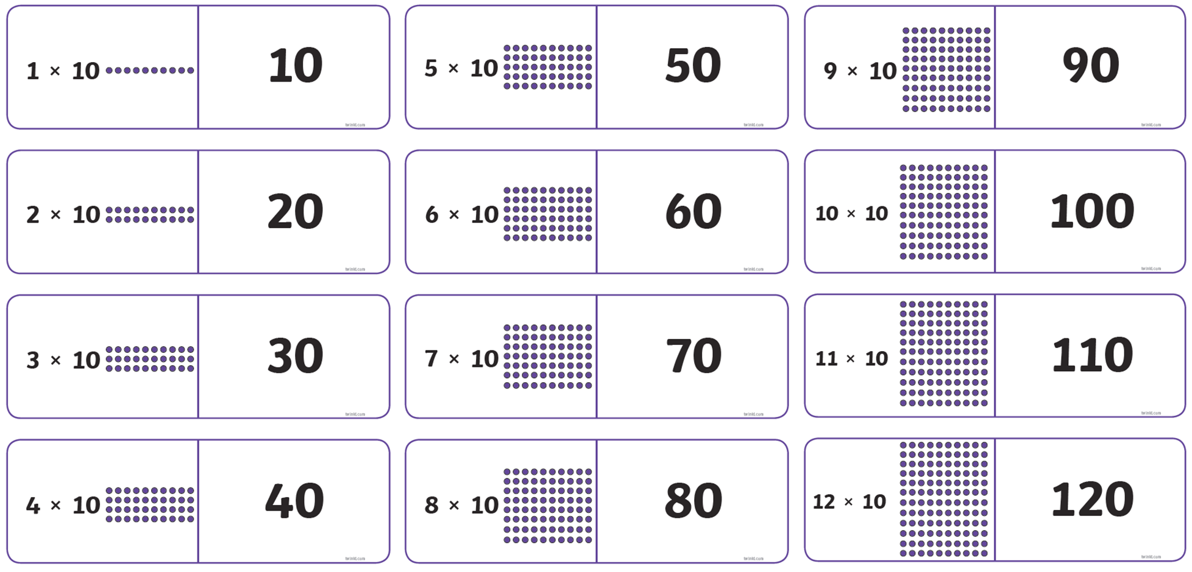

Challenge 1

Cut up the dominos and then match the 10 times table pairs.