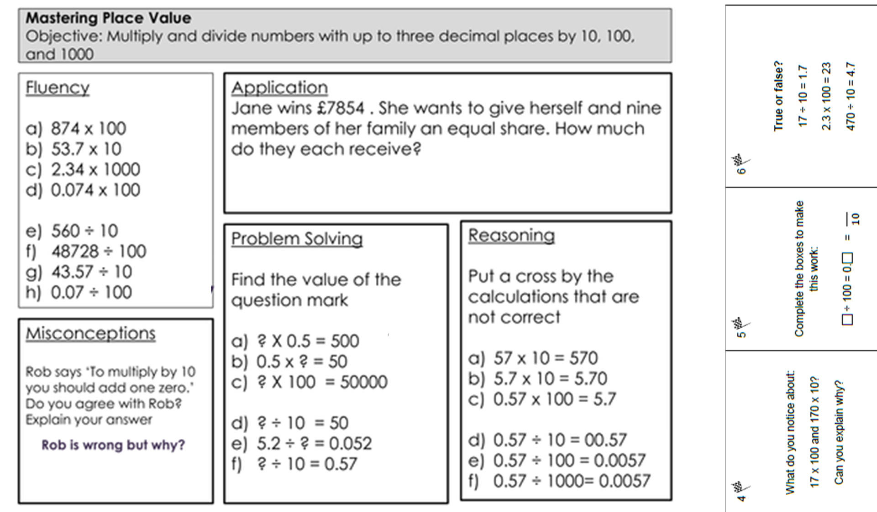

Challenge 3

Complete the mastery questions and the three flag questions.