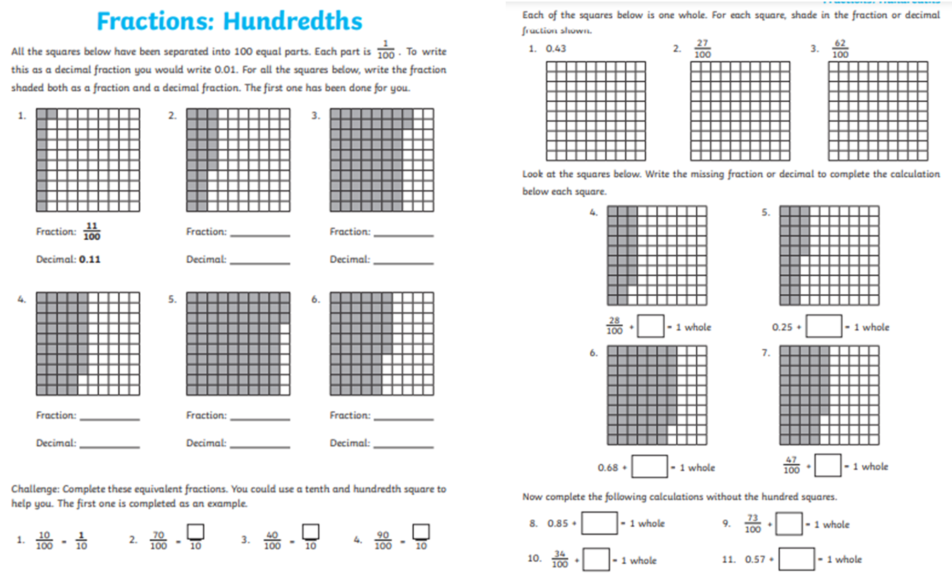

Challenge 2

Complete the hundredths fractions and decimal questions.