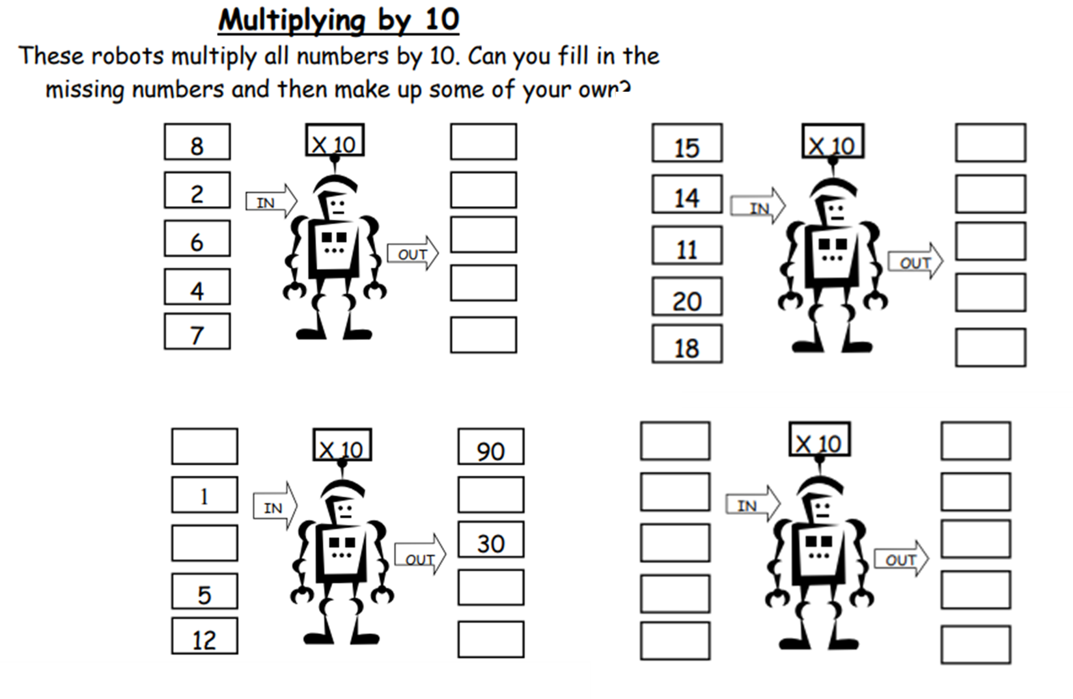

Challenge 1

Fill in the missing multiply by 10 robot numbers and then complete some of your own.