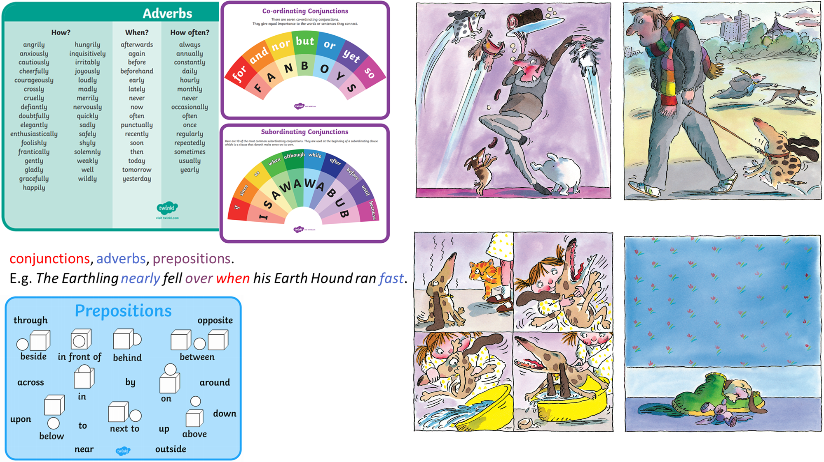

Use the adverbs, conjunctions and prepositions to write some interesting sentences about the pictures from the book.

