 | Monday | Tuesday | Wednesday | Thursday | Friday
9-9:15 | Spellings  Practice the words  find careless  hopeless useless  faultless agreement  movement treatment  payment floor | Spellings  Practice the words  find careless  hopeless useless  faultless agreement  movement treatment  payment floor | Spellings  Practice the words  find careless  hopeless useless  faultless agreement  movement treatment  payment floor | Spellings  Practice the words  find careless  hopeless useless  faultless agreement  movement treatment  payment floor | Spelling Test  Log on to Purple Mash or do with a grown up
9:15-10:15 | English  See separate folder for resources.  Lesson 1 Alien Tea Phonics | English  Lesson 2 Alien Tea Sentences | English  Lesson 3 Alien Tea Favourites | English  Lesson 4 Alien Tea  Song and recipe | PSHE  What was the best thing about the school year so far?
10:30-11 | Snack time/Movement Break  Keep healthy with a piece of fruit, veggie sticks, yoghurt or cheese and crackers and a drink
11-12 | Maths  Video: Week 11 Day 1  2do questions on Purple Mash  Worksheets below double click to open in pdf format | Maths  Video: Week 11 Day 2  2do questions on Purple Mash  Worksheets below double click to open in pdf format | Maths  Video: Week 11 Day 3  2do questions on Purple Mash  Worksheets below double click to open in pdf format | Maths  Video: Week 11 Day 4  2do questions on Purple Mash  Worksheets below double click to open in pdf format | Maths -Game  Education City time game has been assigned to you.
12-1 | Lunch | Lunch | Lunch | Lunch | Lunch
1-1:30 | Reading  Purple Mash Serial Mash  Bramble the Bold  Chapter 4  2do | Reading  Purple Mash Serial Mash  Bramble the Bold  Chapter 5  2do | Reading  Purple Mash Serial Mash  Percy the Poorly Pony Chapter 1  2do | Reading  Purple Mash Serial Mash  Percy the Poorly Pony  Chapter 2  2do | Reading  Purple Mash Serial Mash  Percy the Poorly Pony  Chapter 3  2do
1:30- 2:30 | Jungle  Write a rainforest postcard on the 2do Purple Mash or paper. What would you see, hear, feel? | Jungle  Mind Map  Make a mind map of all the things you have learnt about the rainforest. | Jungle  PE  Dance! Can you create your own Rainforest Dance. | Jungle  Art  Try using chalk to draw some rainforest animals.  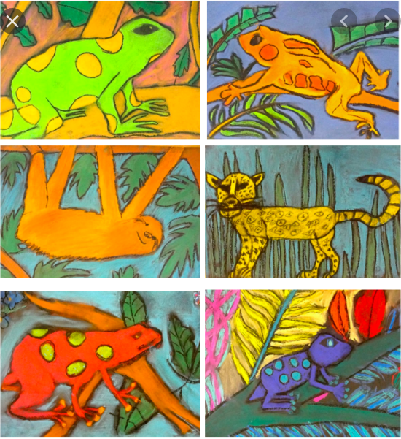 | Friday Fun Challenge  No challenge this week –school is finished.

