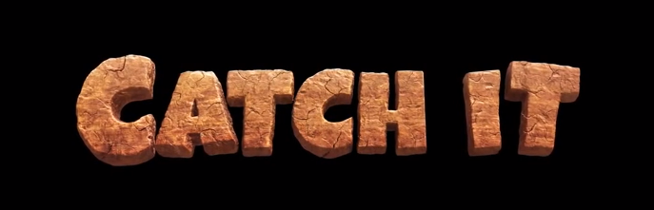
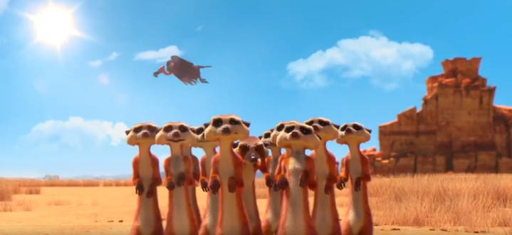

- What is the name of the long, seasonal sleep that some mammals partake in during the winter?

- Describe the landscape around the meerkats – what is their natural habitat?

- Do you think the vulture is the hero or the villain? Explain your answer.

- Why do you think all of the animals are so desperate to catch the fruit?

- Explain how the meerkats work as a team, once they have got the fruit.

- Who do you think won in the end, the vulture or the meerkats and why?

