 | Monday | Tuesday | Wednesday | Thursday | Friday
9-9:15 | Spellings  Practice the words  eye magical  hospital animal  total fast  word worst  work worry | Spellings  Practice the words  eye magical  hospital animal  total fast  word worst  work worry | Spellings  Practice the words  eye magical  hospital animal  total fast  word worst  work worry | Spellings  Practice the words  eye magical  hospital animal  total fast  word worst  work worry | Spelling Test  Log on to Purple Mash or do with a grown up
9:15-10:15 | English  See separate folder for resources.  Mr Frog Comprehension | English  A letter from the hospital. | English  Antonyms | English  Punctuation | R.E.  How can I care for my community? Find out about a local charity in Borehamwood and what they do.  2DO available
10:30-11 | Snack time/Movement Break  Keep healthy with a piece of fruit, veggie sticks, yoghurt or cheese and crackers and a drink
11-12 | Maths  Video: Week 8 Day 1  2do questions on Purple Mash  Worksheets below double click to open in pdf format | Maths  Video: Week 8 Day 2  2do questions on Purple Mash  Worksheets below double click to open in pdf format | Maths  Video: Week 8 Day 3  2do questions on Purple Mash  Worksheets below double click to open in pdf format | Maths  Video: Week 8 Day 4  2do questions on Purple Mash  Worksheets below double click to open in pdf format | Maths -Game  Scavenger hunt write down the answers to 2 3 5 10 times tables. Hide around the house then the children hunt these. Then give the answer.
12-1 | Lunch | Lunch | Lunch | Lunch | Lunch
1-1:30 | Reading  Purple Mash Serial Mash  Charlie and the Camper Van Chapter 4  2do | Reading  Purple Mash Serial Mash  Charlie and the Camper Van Chapter 5  2do | Reading  Purple Mash Serial Mash  A Village Full of Vegetables Chapter 1  2do | Reading  Purple Mash Serial Mash  A Village Full of Vegetables Chapter 2  2do | Reading  Purple Mash Serial Mash  A Village Full of Vegetables  Chapter 3  2do
1:30- 2:30 | Jungle  Read about the rainforest and palm oil. Write down three facts you have learned. | Jungle  Play some rainforest games online and learn at the same time! https://www.rainforest-alliance.org/kids | Jungle  PE  https://family.gonoodle.com/activities/roar | Jungle  Make a paper plate parrot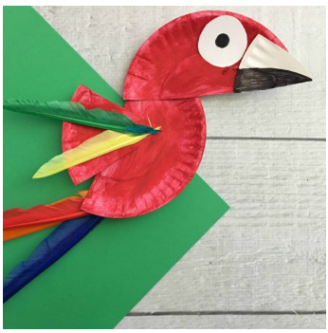 | Friday Fun Challenge  1000 steps challenge  Can you get 1000 steps in this weekend by walking, climbing stairs, doing star jumps etc

