Capitalisation and Full Stops
Task: Find and circle the letters in the paragraph that should be capitalised. Your teacher has made another mistake she has forgotten to put full stops. Once you have corrected out all the errors, rewrite the paragraph in your best handwriting.

it was Saturday at grandma’s house mary knew that it was the day to make a pie with grandma she got up and dressed in a hurry so she could pick the best apples from the tree she helped peel the apples while her grandma chopped and sliced the beautiful red apples next, the dough was rolled and put into the pie plate mary even got to stir the sugar and spices into the bowl the house smelled wonderful as the pie cooked in the oven, and the pie tasted even better because they had made it together!
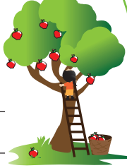
Write two sentences about the picture. Don’t forget the capitals!

