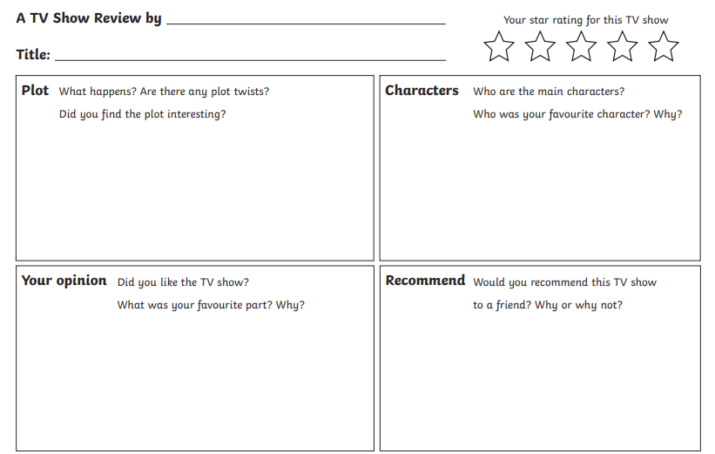
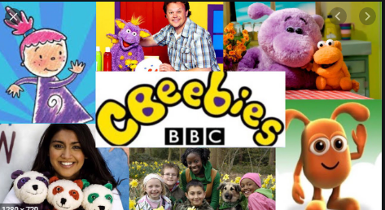

Write a review of a TV programme you know. Don’t forget to explain what it is about and who the main characters are, as well as saying what you think of it.

Word Bank: show family recommend channel favourite exciting actors brilliant
funny cartoon characters watch action

