Collective nouns are used to name a group of animals.

A group of meerkats is called a ‘mob’.

Here are some examples:
- A school of fish
- A murder of crows
- A herd of elephants

Look at these animals below, can you find out the collective nouns for a group of each?
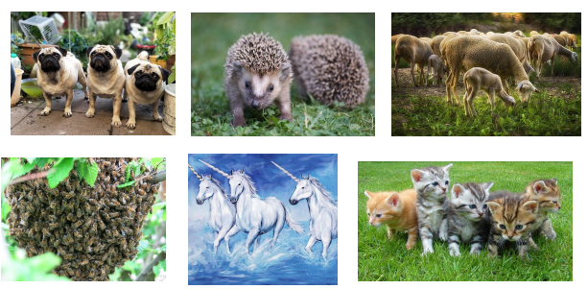

Can you find anymore examples of your own?

