Retelling story and comprehension

1. It’s story time!
Listen to award-winning storyteller Wilf Merttens read the traditional Russian folk story, Baba Yaga and the Black Geese at

https://www.youtube.com/watch?v=IvbL4W52bJM&t=831s.
(The story is about 20 minutes long.)

2. Comprehension
Read each of the Questions about Baba Yaga and the Black Geese and write down your answers in the spaces provided.
- Ask if you can watch part of the story again if you need to check something.
- Remember to check all of your answers to be sure that you have actually written down what you wanted to.

3. Retelling a story
You are going to retell the story of Baba Yaga and the Black Geese as if you were the storyteller in the video!
- Read the Story Telling Hints to help you get ready for your retelling.
- Use the Story Map to help you remember all the different parts of the story and the order they go in.

Extension: Now try these Fun-Time Extras
• Retell the story for an audience.
• Get Mum or Dad to film you retelling the story so that you could let other people in your family see it later.

Questions about Baba Yaga and the Black Geese

- What sort of toys were Sergei and Olga playing with when Baba Yaga’s black geese appeared?
- Draws lines to show which animal gave Olga which gift on her journey to look for Sergei.
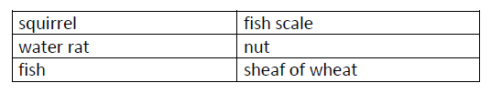
- After she has received all her magic gifts, Olga goes into the forest. What is it like in the forest?
- True or False? Baba Yaga’s house in the forest has legs it can walk around on.
- Name some of the traps that Baba Yaga has in her house:
- There is something a bit funny about how Baba Yaga sleeps. What is that?
- Whereabouts in the house was Sergei being kept by Baba Yaga?
8. Olga uses her magic gifts to help them get away from Baba Yaga. What does each gift make happen? The first one has been done for you.
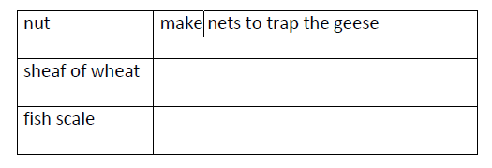
9. What sort of things did they find inside Baba Yaga once she had been exploded by Sergei’s helicopter toy?
Story telling hints:
When you tell a story to an audience, you should:
• Use a performance voice, which is a bit louder than your usual talking voice, so the audience can hear you.
• Use a different voice for different characters, so that people can tell when a new person is speaking your story.
• Change the tone of your voice depending on what is happening in the story. Make your voice gentle and slow for quiet moments in the story; make it urgent and quick for scary or exciting bits.
• Speak clearly, so that what you say doesn’t confuse people.
• Look at the faces of the audience and into their eyes, so that everyone will be interested in you!
• If you get a bit lost, DON’T PANIC! Just pause and remember what happens next so that you can carry on.

