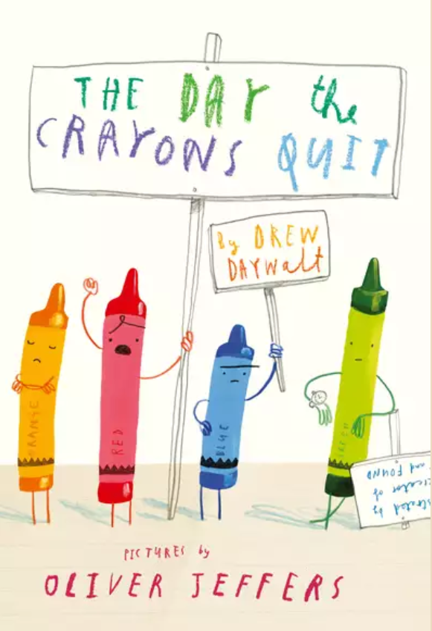
This is the front and back cover of the book ‘The Day the Crayons Quit’. Look at the pictures carefully and read the blurb. Then answer the questions below. Have a go at the Challenge Questions if you can.
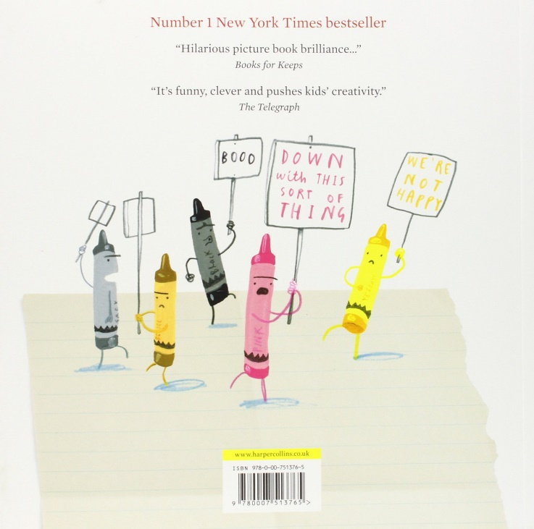

Poor Duncan just wants to colour in. But when he opens his box of crayons, he only finds letters, all saying the same thing: We quit.
Beige is tired of playing second fiddle (cheat) to Brown, Blue needs a break from colouring in all that water, while Pink just wants to be used. Green has no complaints, but Orange and Yellow are no longer speaking to each other.
The battle lines have been drawn. What is Duncan to do?

Q.1. What do the illustrations or drawings on the back cover show you? What are they doing?
Q.2. Why do you think they are doing that?
Q.3. How do you think Pink Crayon is feeling? How can you tell that?
Q.4. Who is Duncan?
Challenge Questions:
Q.5. Why does the author call him ‘Poor Duncan’ in the first sentence of the blurb?
Q.6. Why do you think ‘Pink just wants to be used’?

